Sanner’s Carbine Classic May Match Report
7/30/2022

The July Carbine Classic match featured a beautiful break from the sweltering summer weather, but certainly no break from the heat of competition! The day before brought rain which unfortunately meant all setup had to be done the morning of the match, but our dedicated RO’s and competitors got it done with minimal delay to the match!

Stages for this match presented high levels of movement as well as a drill that really focused on a competitor’s ability to control their balance of speed and accuracy. All in all, a good test for the tactical rifleman focused on the practical application of marksmanship in a short range environment.

A trio of brave souls decided to spit in the face of the beautiful weather and compete in prepper division. Two seasoned preppers and one new tried the challenge of keeping all their gear and equipment they needed for the match on their person throughout the entire match. This included their rifles, plenty of water, food, ammunition, spare parts, etc. Congratulations to every prepper for completing the match but a special congratulations goes to Anibal Delgado for winning prepper division and placing fourth overall!

Additional recognition must be given to Bradley Harold as the top Active Duty competitor, Gary Turner as the high senior, and Andrea Swierczek as the high lady! Great shooting!

Included below is the link to the scores posted on Practiscore and below that are a few photos snagged during the match.

https://practiscore.com/results/new/176008

The next match will be October 29th; as usual sign-ups will be announced a couple weeks in advance.

-Jake Swierczek

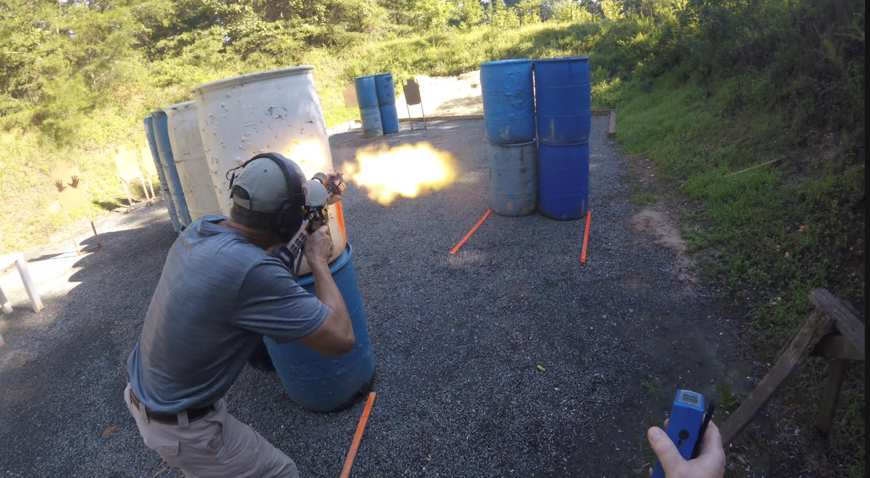
The weather wasn’t the only source of warmth!

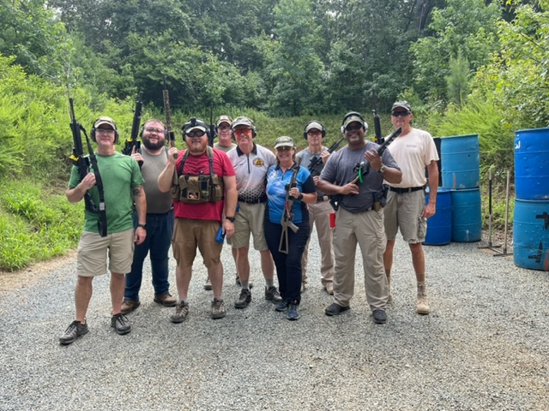
Happy competitors are returning competitors
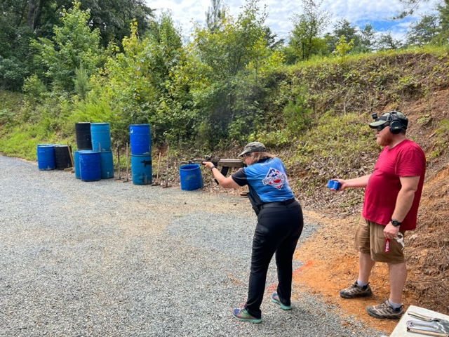
It’s all fun and games until the AKs come out to play!

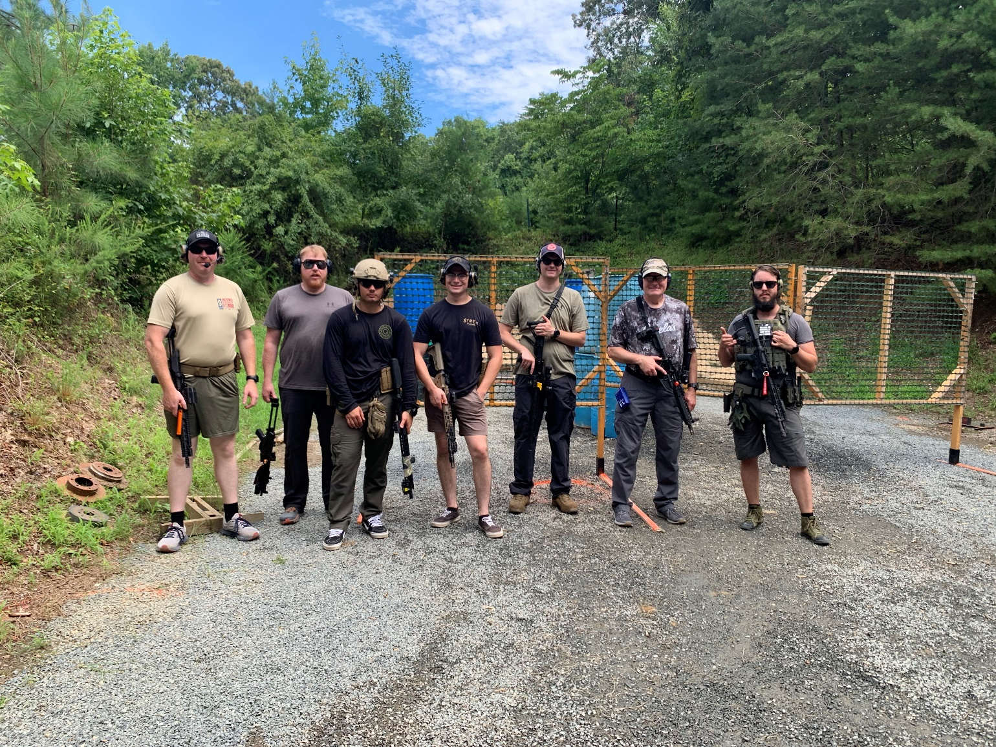
We can’t get enough squad pics!
