Sanner’s Carbine Classic March Match Report
3/19/2022

The March Carbine Classic match was a perfect way to start the new season! A cool morning turned to perfectly sunny weather as the day went on and competitors blasted off the cobwebs.

Stages for this match emphasized movement and flow with point-blank targets placed at the far end of the bay where running speed would be tested, or hallways where efficient target engagement would win the stage. Plenty of weak-side shooting added to the challenge to make odd positions without rolling around on the ground.

As usual, Prepper division had a strong core following with 5 veterans of the division showing that this match simply is not hard enough without wearing all the gear and equipment they needed for the match on their person throughout the entire match, including water, food, ammunition, spare parts, etc. Congratulations to every prepper for completing the match but a special congratulations go to Anibal Delgado once again for winning prepper division!

Prepper division is not the only way to make this match harder though. Instead of spending big bucks on whatever latest and greatest red dot or scope is making the rounds on YouTube, three competitors chose to put their eyesight to the test and get back to basics with good old iron sights for this match. Congratulations to all our Ironmen, but especially Brad Drouillard for taking first in this division at his first Carbine Classic, with an M1 Carbine no less!

Last but obviously not least, congratulations to David Metcalfe for his overall win, edging out the next competitor by just over 3 seconds, nice job!

Additional recognition must be given to Mike Hansen as the top Active Duty competitor, and Andrea Swierczek as the high lady! Great shooting!

Included below is the link to the scores posted on Practiscore and below that are a few photos snagged during the match.

https://practiscore.com/results/new/162060

The next match will be May 7th; as usual sign-ups will be announced a couple weeks in advance.

-Jake Swierczek

Junior shooters stepping up to the plate…

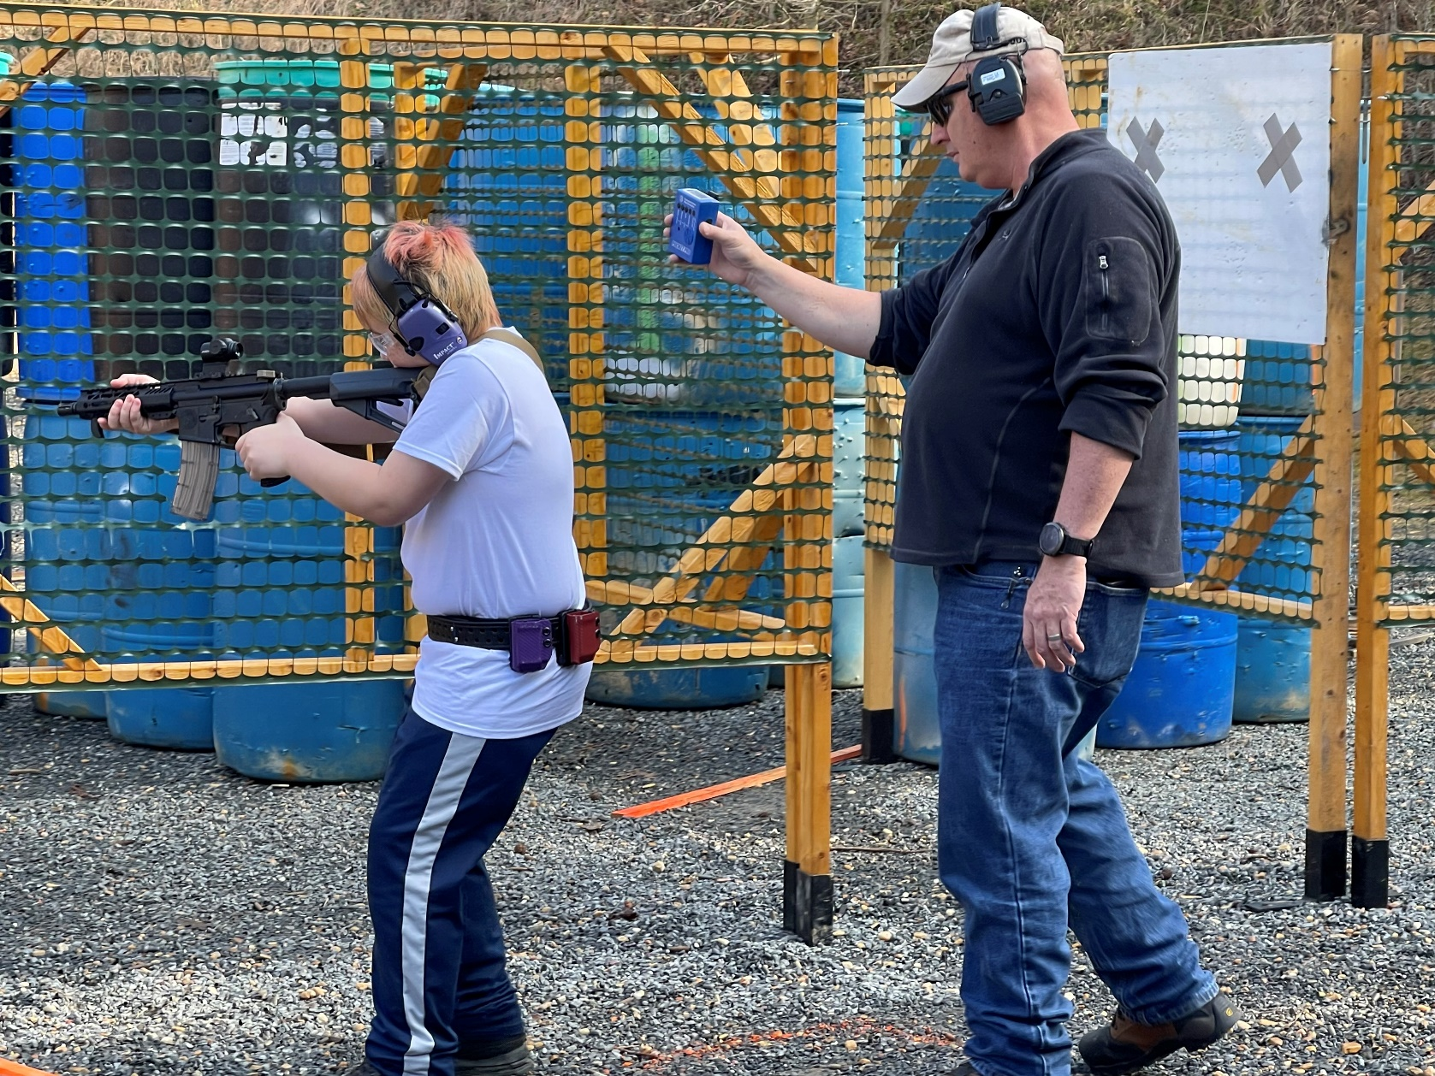

…and keeping the heat on the old-timers with timers!

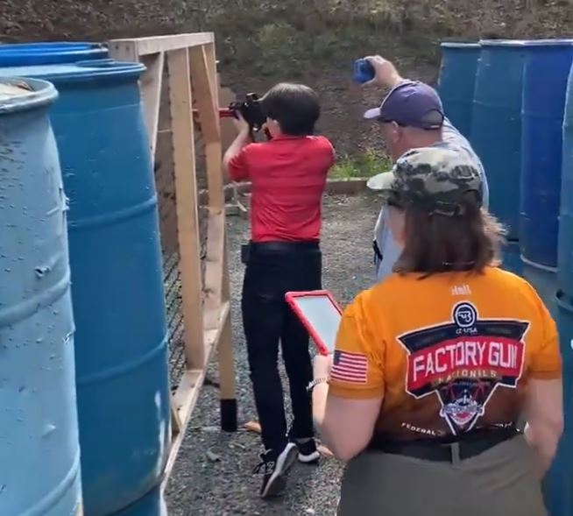

One of several satisfied squads of shooters!

