Sanner’s Carbine Classic May Make-Up Match Report
6/19/2021

We beat the heat at this month’s Sanner’s Carbine Classic, but unfortunately the humidity is another story. While those in Prepper division looked particularly soaked everyone was certainly damp when the brass stopped flying.

Stages this match were a fun balance of running and gunning and some that offered competitors a few different options. As always, those in Prepper carried the day as well as all their gear, ammo, and rifles! During such a warm and humid day completing the match and avoiding dehydration is not trivial, and that is before some Preppers decided to take it upon themselves to wear armor. Congratulations are in order for every Prepper, but especially to Anibal Delgado for taking first in that category! An honorable mention must be made to Michael Siewertsen for being the top Prepper who wore armor; great shooting guys!

In the end it was Daniel Goodwin who took the day with a stunning final score, beating the next competitor by nearly 20 seconds, great performance!

Included below is the link to the scores posted on Practiscore as well as a couple photos snagged during the match.

https://practiscore.com/results/new/138749

Special recognition must be given to Bart Noffsinger as our only Ironman competitor, Jack Perrin as the top Active Duty competitor, Glenn Kahler as the high senior, Andrea Swierczek as the high lady, and finally Carson Focht as top Junior! Great shooting!

The next match will be July 31st, which I suspect will bring hotter weather and even hotter competition! Sign up information will be provided separately; stay tuned to the Sanner’s website for the status of upcoming matches.

-Jake Swierczek

Avoiding the no-shoot

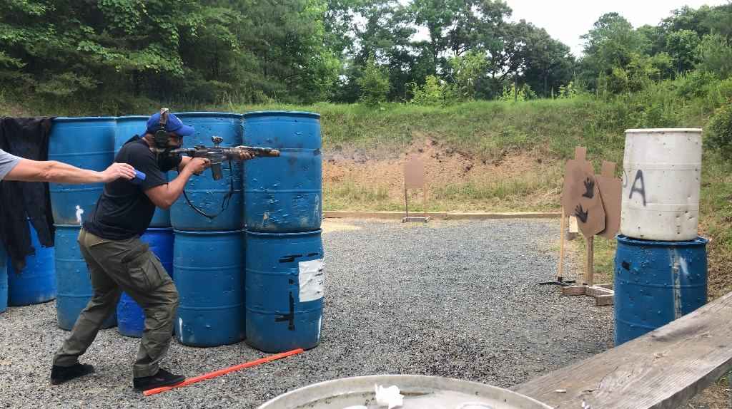

In the thick of the action
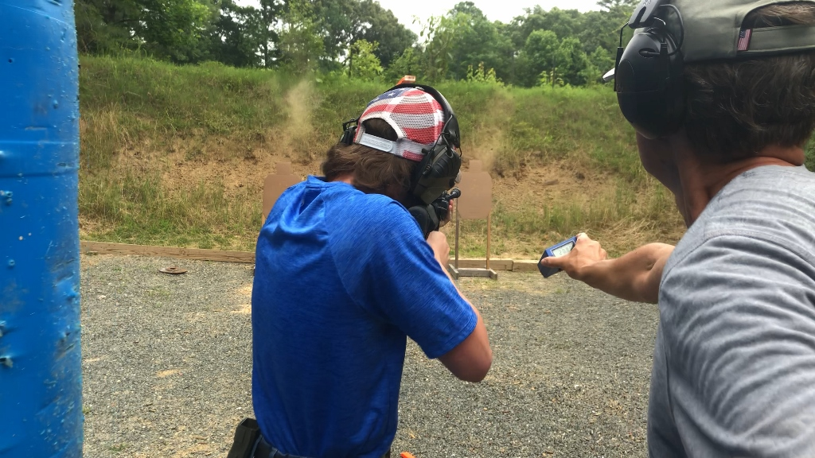
Threading the needle
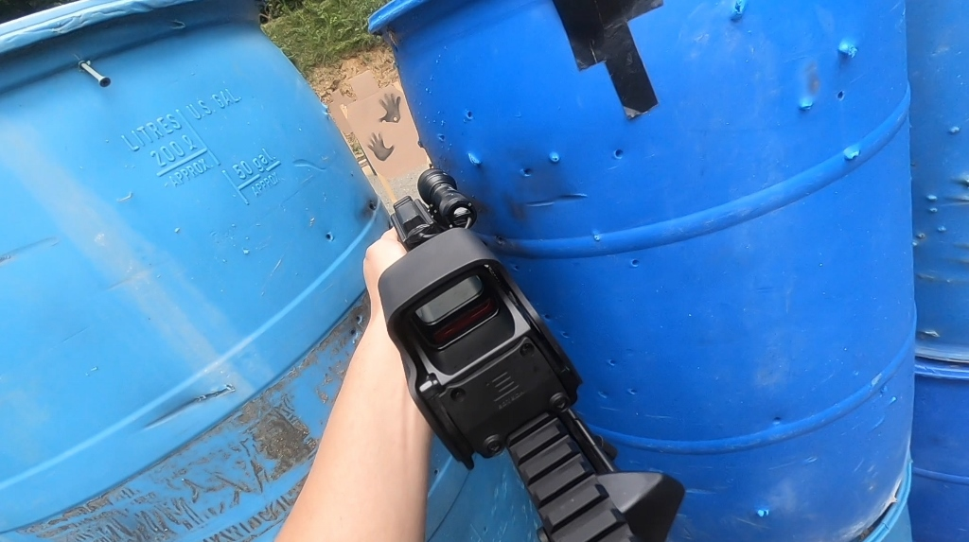
Working on a closed bolt reload
