Sanner’s Carbine Classic September Match Report
10/29/2022

A crisp cool fall day gave way to warm sun as the competition heated up at the October 2022 Sanner’s Carbine Classic!

Stages for this match were all Halloween themed with zombies, missing limbs, and scarecrows. All stages for the match were based on the September IDPA match which emphasized simple, fast stages, all with 18 rounds, no no-shoots, no movers, and no hardcover challenges. This allowed competitors to focus on running their rifle, rocking their costume, and avoiding any Halloween decorations that might have otherwise gotten in the way.

As always, those in Prepper pulled their weight as well as their gear, ammo, and rifles. Even on such a cool crisp day the weight and bulk of equipment and costumes is no trivial factor. Congratulations to every Prepper that completed the match, but it was Nic Aumann taking first in that category beating out seasoned veteran Anibal Delgado by only 3 seconds.

In addition to prepper, the Ironman division made a good showing once again with 6 competitors showing the world that their eyes still work fine. In the end it was Tim Kelly who needs glasses the least placing first in Ironman division and fifteenth overall, great shooting!

Overall, Matt Cooper took the win at his first carbine match in a while, edging out David Metcalfe both of whom used PCCs to take the lead!

Included below is the link to the scores posted on Practiscore as well as a couple photos snagged during the match.

https://practiscore.com/results/new/185677

Special recognition must be given to Dwayne Stevenson as the top Active Duty competitor, Paul Goodwin as the high senior, Andrea Swierczek as the high lady, and finally Joseph Murphy as top Junior! Great shooting!

The next match will be December 31st; as usual sign-ups will be announced a couple weeks in advance.

-Jake Swierczek
Sure, it’s a complicated weak hand reload…but how is he holding that rifle?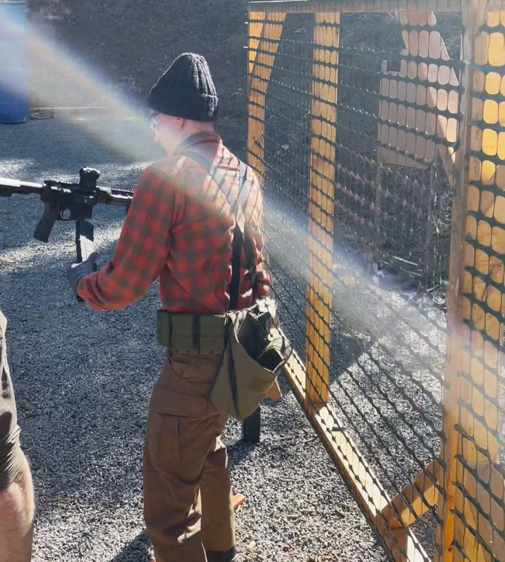

On the other hand, some folks just refuse to go weak side:
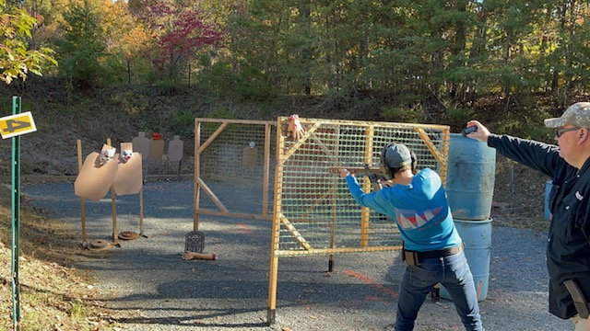

Competitors showing their Halloween spirit…and getting their match fees waived!
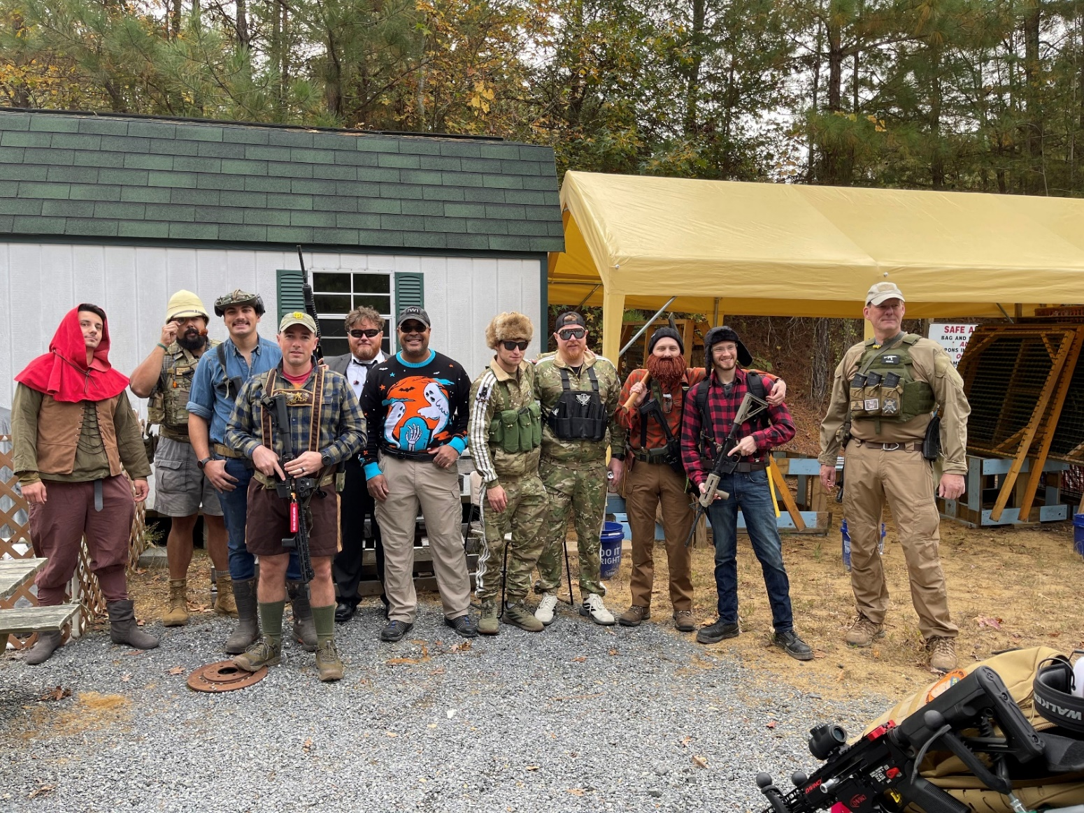
Two of several happy squads:
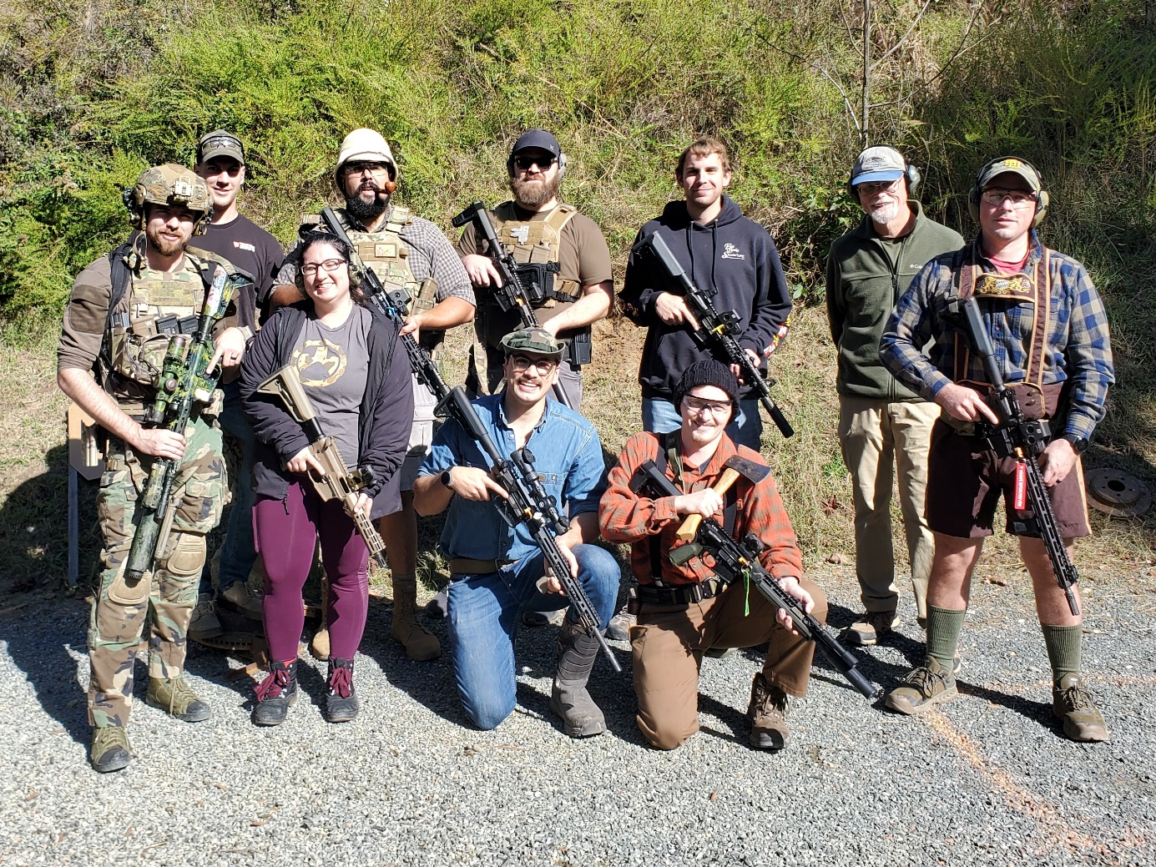

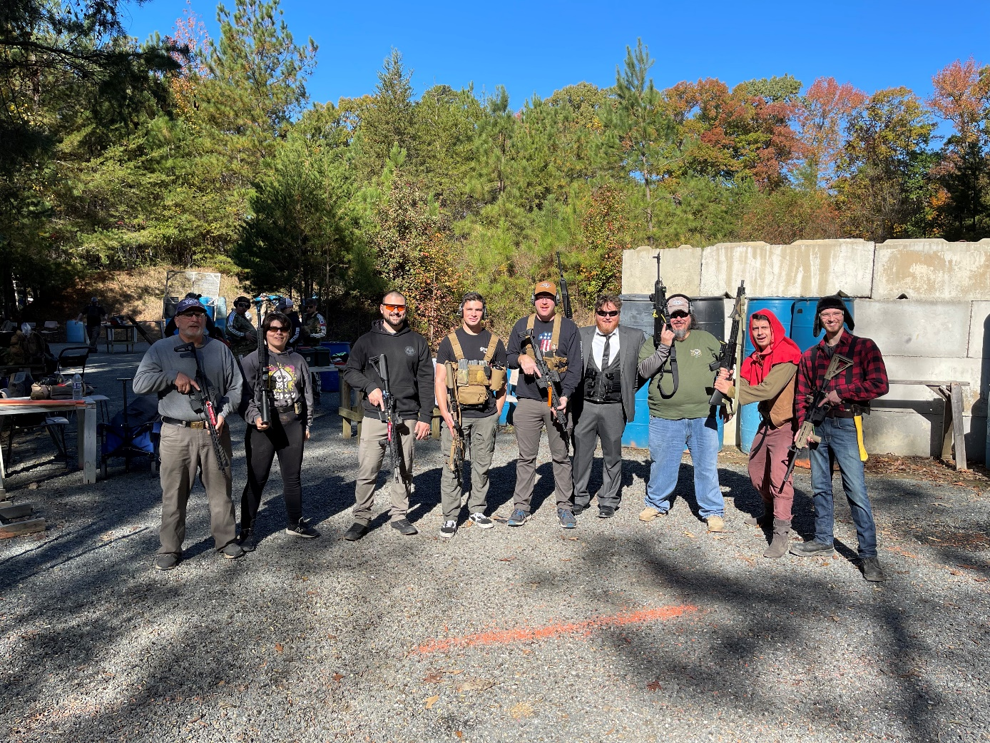

Straight from the 1800s, here’s a true “Tactical Victorian” in the flesh:
