Southern Maryland 2 Gun Summer 2022 Match Report
7/16/2022

Warm temperatures and stifling humidity greeted competitors for the second Southern Maryland 2 Gun match at Sanner’s Lake Sportsmen’s Club. The sizzling sun and soaking sweat, although not very comfortable, were appropriate for a summer match and nicely balanced the wintry snow and shivers at our last match in January.

With the occasional breeze keeping things somewhat bearable, competitors were able to put their gear to the test with fun action-packed stages including mental, physical, and shooting skill-based challenges keeping the match interesting. Challenging targets at 100 yards and even a diabolical spinner kept competitors on their toes and rewarded patience and accuracy with satisfying clangs of well-placed hits on steel.

The most dramatic effect of the humidity was on Prepper division. These competitors had to carry all their gear for every stage on their person throughout the day. This included food, plenty of water, spare parts, tools, and let’s not forget their rifle, pistol, magazines, and ammunition for both guns! When the weather is warm and humid like this, the challenge is amplified and the risk of not having enough supplies is significant. Congratulations to Matt Thompson for being the only soul brave (or foolhardy) enough to make the attempt; a victory by default is a victory nonetheless!

Included below is the link to the scores posted on Practiscore as well as a couple photos snagged during the match.

https://practiscore.com/results/new/174421

Special recognition must be given to Joseph Livi as the top Active Duty competitor and Andrea Swierczek as the high lady! Great shooting!

The next Southern Maryland Two Gun match will be this Winter, so be ready to fight the exact opposite conditions for glory.

-Jake Swierczek and Jeremy Hanson
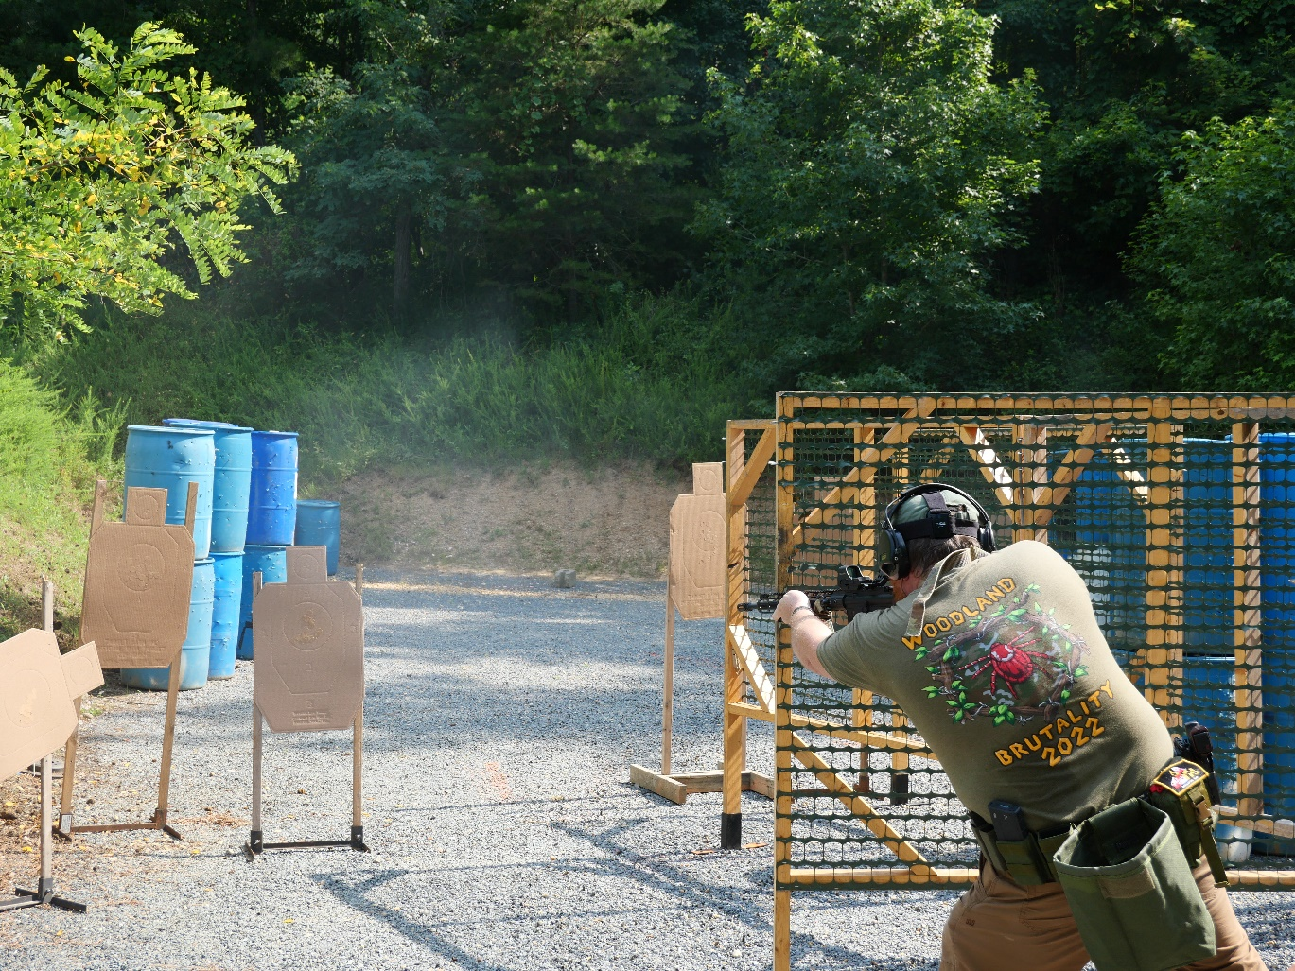
Lean or go left-handed, one may be easier but which is easier for you?

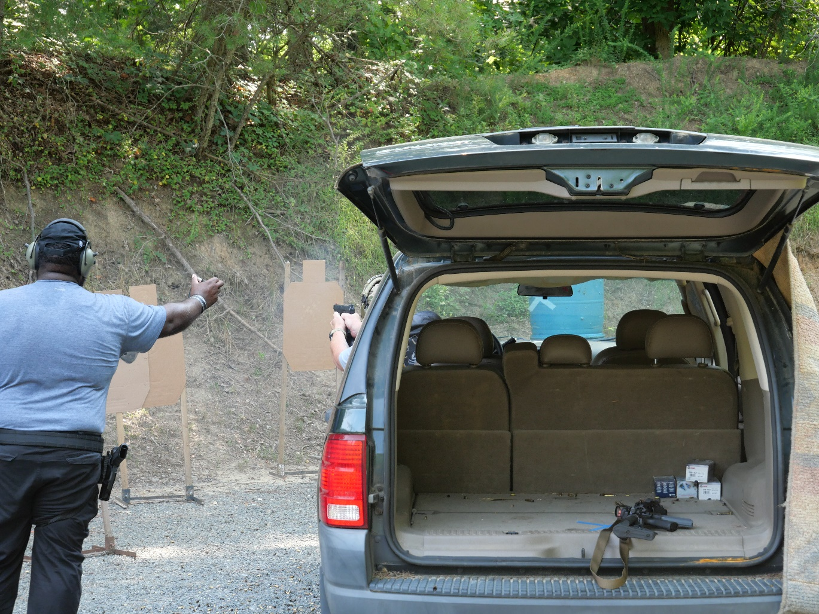
Shooting from a car provides many unique challenges, mostly how does one manage to have so much fun?
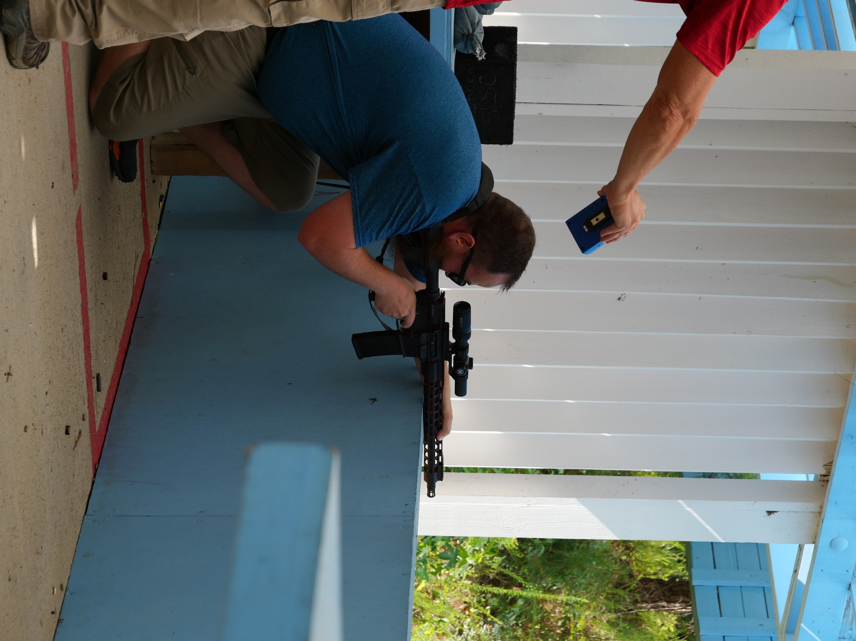
When available, use support!

