Southern Maryland 2 Gun Winter Match Report
1/8/2022

A cold but sunny day greeted competitors for the first Southern Maryland 2 Gun match at Sanner’s Lake Sportsmen’s Club. With some snow left on the ground and a chill in the air, conditions were perfect for a winter match.

Despite the sun's best efforts, the cold affected electronic timers, hearing protection, target pasties, and the competitors themselves as fingers froze and basic tasks became more difficult. Despite the hardship, a fun match was had by all, with new shooters eager to take a turn and hone their skills, and veteran shooters champing at the bit for more two gun matches throughout the year.

As we evolve and improve this match, divisions and rules may be tweaked here and there but one constant will certainly be the challenge of Prepper division. These competitors had to carry all their gear for every stage on their person throughout the day. This included food, water, extra clothing, hand warmers, spare parts, tools, and let’s not forget their rifle, pistol, magazines, and ammunition for both guns! Even when the weather is chilly, the weight and bulk of such equipment is no trivial factor. Congratulations to every Prepper that completed the match, but it was Anibal Delgado who overcame the conditions to coldly seize victory in that division!

As the match evolves, one division we are looking at modifying is Open division. With our current range constraints, the advantages of Open really do not make a big difference. Finding incentive to shoot open is difficult and currently any optic on a competitor’s pistol would automatically put them in open whether or not they want to be there. As we continue to run and improve this match, keep an eye out for those things evolving as we try to solve these problems for the competitors.

Included below is the link to the scores posted on Practiscore as well as a couple photos snagged during the match.

https://practiscore.com/results/new/156598

Special recognition must be given to Jack Perrin as the top Active Duty competitor, and Andrea Swierczek as the high lady! Great shooting!

The next Southern Maryland Two Gun match will be in the summer of 2022, so be ready to fight the exact opposite conditions for glory.

-Jake Swierczek and Jeremy Hanson

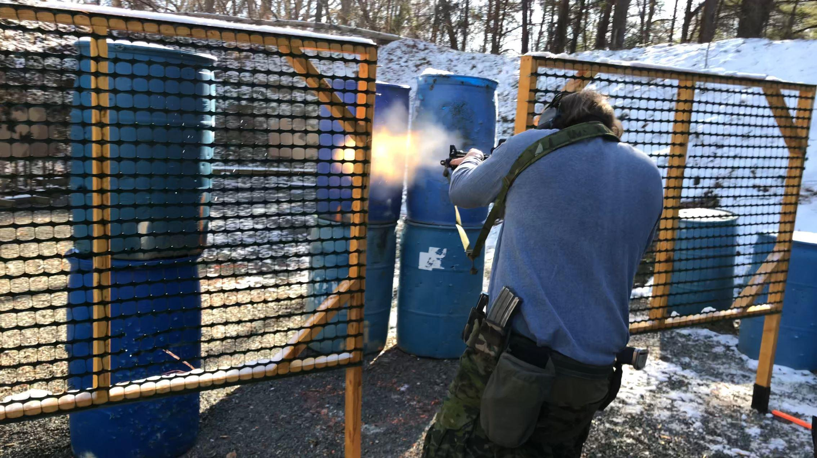
Dynamic shooting and dynamic fire!

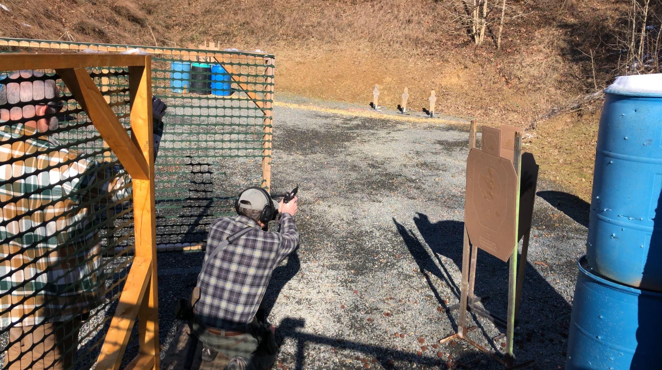
A two gun match requires both pistol and rifle proficiency
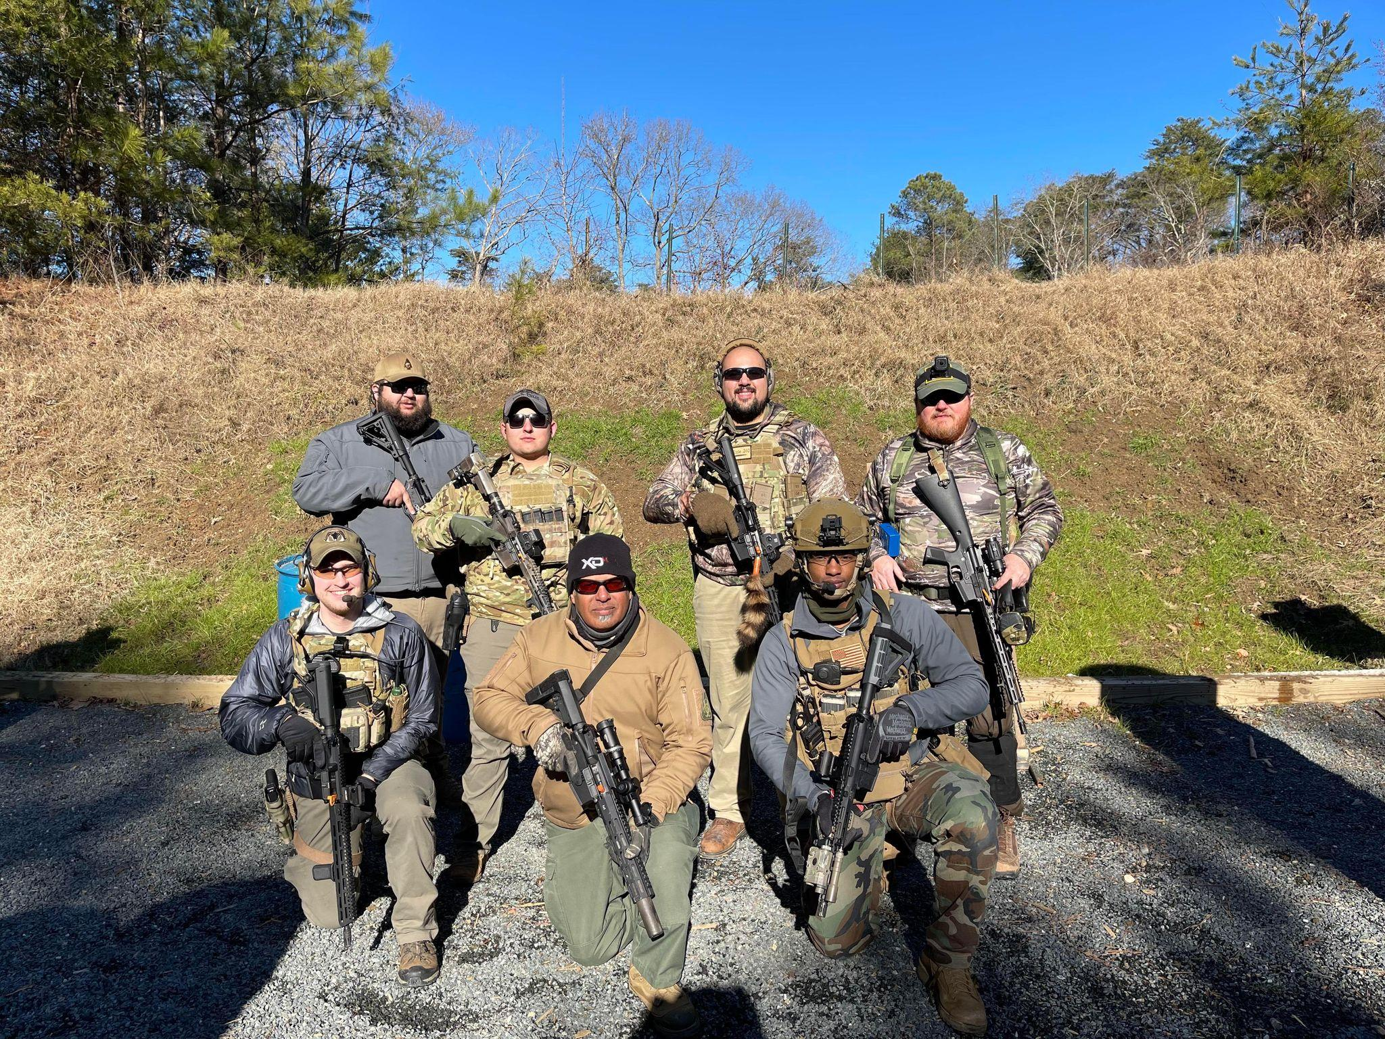
The mostly Prepper squad showing how camaraderie is done

