Southern Maryland 2 Gun Winter Match Report
2/18/2023

After a major front moved through the day before a cold but relatively calm and sunny day greeted competitors for the second winter Southern Maryland 2 Gun match at Sanner’s Lake Sportsmen’s Club. While this match saw no snow like last year the morning chill certainly made up for it.

The atmospheric conditions of the day made the range seem quiet despite the shooting, but we like to think it was because more people were shooting suppressed than usual. Regardless, it is good to see the trend and hopefully it continues.

Despite the challenging conditions and match, some competitors choose to make it even more rough on themselves by competing in Prepper division. These competitors had to carry all their gear for every stage on their person throughout the day. This included food, water, extra clothing, hand warmers, spare parts, tools, and let’s not forget their rifle, pistol, magazines, and ammunition for both guns! Even when the weather is chilly, the weight and bulk of such equipment is no trivial factor. Congratulations to every Prepper that completed the match, but it was Robert Platt who took his first prepper win!

Included below is the link to the scores posted on Practiscore as well as a couple photos snagged during the match.

https://practiscore.com/results/new/194485

Special recognition must be given to Patrick Murphy as the top Active Duty competitor, Andrea Swierczek as the high lady, and Joseph Murphy as the top junior! Great shooting!

The next Southern Maryland Two Gun match will be in the Summer of 2023, so be ready to fight the exact opposite conditions for glory.

-Jake Swierczek and Jeremy Hanson

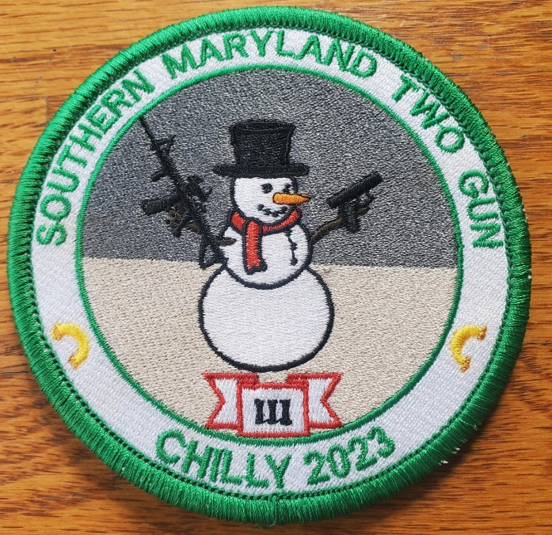

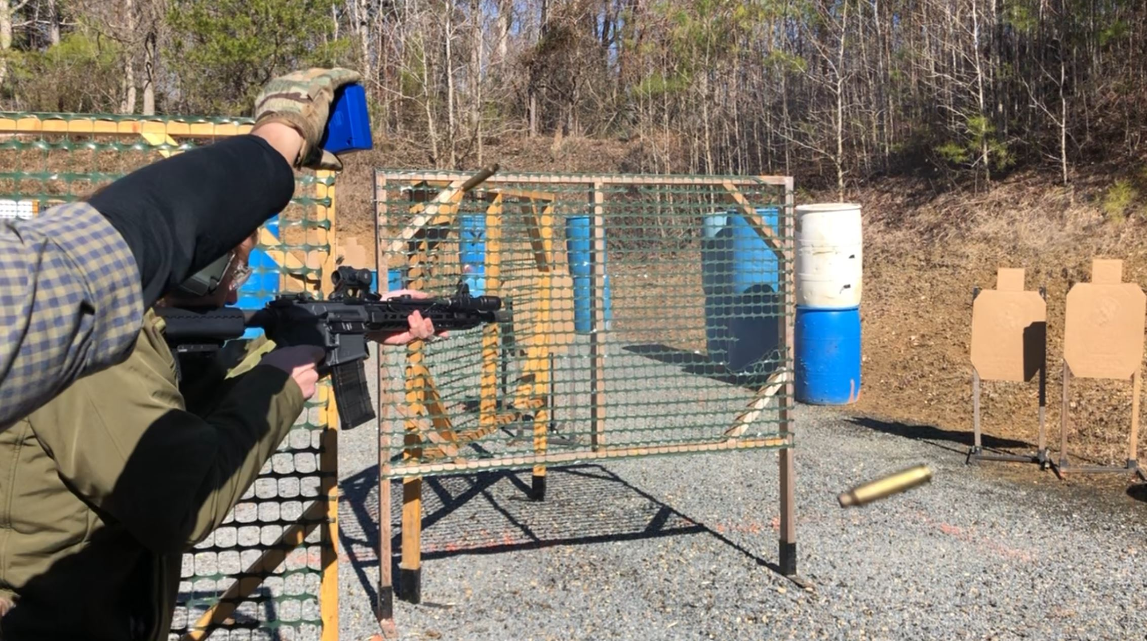

Sometimes the makeup shots come fast and heavy!

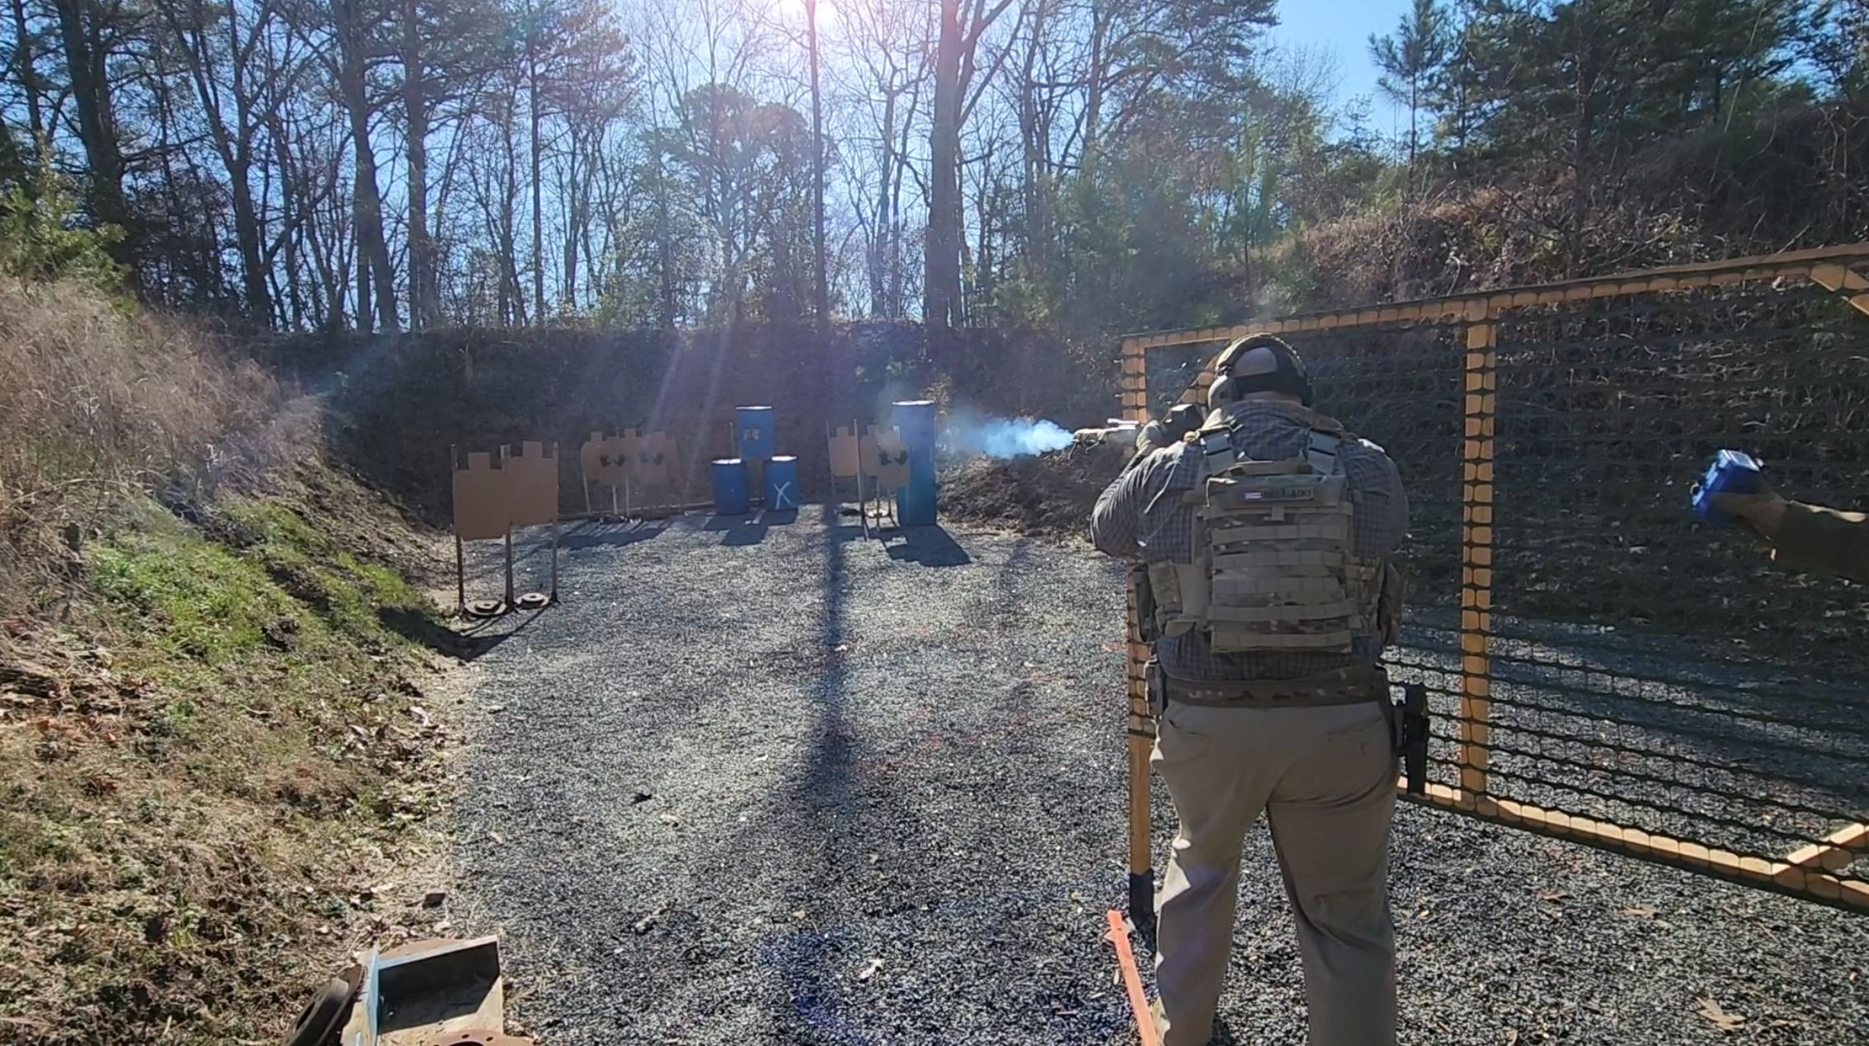

Cool air and hot suppressors make for great smoke signals!

