Sanner’s Carbine Classic September Match Report
12/31/2022

An unseasonably warm but beautifully foggy day greeted competitors for the December 2022 Sanner’s Carbine Classic, with the afternoon rain holding off just long enough to make conditions perfect for the last day of the year match of 2022!

Stages for this match involved various challenges from movement to awkward positions and some mental mind games for a significantly different flavor from the last match. Hopefully this served as a validation of the practice our competitors undoubtedly (?) did throughout the year and helped identify any areas on which to improve in 2023.

As always, those in Prepper pulled their weight as well as their gear, ammo, and rifles. Normally the cool weather makes the weight and bulk of equipment a little less noticeable as one bundles up anyway, however most preppers chose to wear some sort of rain gear which made it a bit less comfortable. Congratulations to every Prepper that completed the match, and kudos to Matthew Reider for taking first in that category.

Amongst the combined group of shooters, Mark Swierczek took his first overall win at a carbine match, and in doing so crushed second place finisher Greg Banta by over 4 seconds. Great shooting!

Included below is the link to the scores posted on Practiscore as well as a couple of photos snagged during the match.

https://practiscore.com/results/new/190425

Special recognition must be given to Damian Bachman as the top Active Duty competitor, Pat Farrar as the high senior, Andrea Swierczek as the high lady, and finally Joseph Murphy as top Junior! Nice job!

The next match will be May 6th, 2023; as usual sign-ups will be announced a couple of weeks in advance.

-Jake Swierczek

Boot failure is just another form of equipment failure! Did you bring a backup pair?

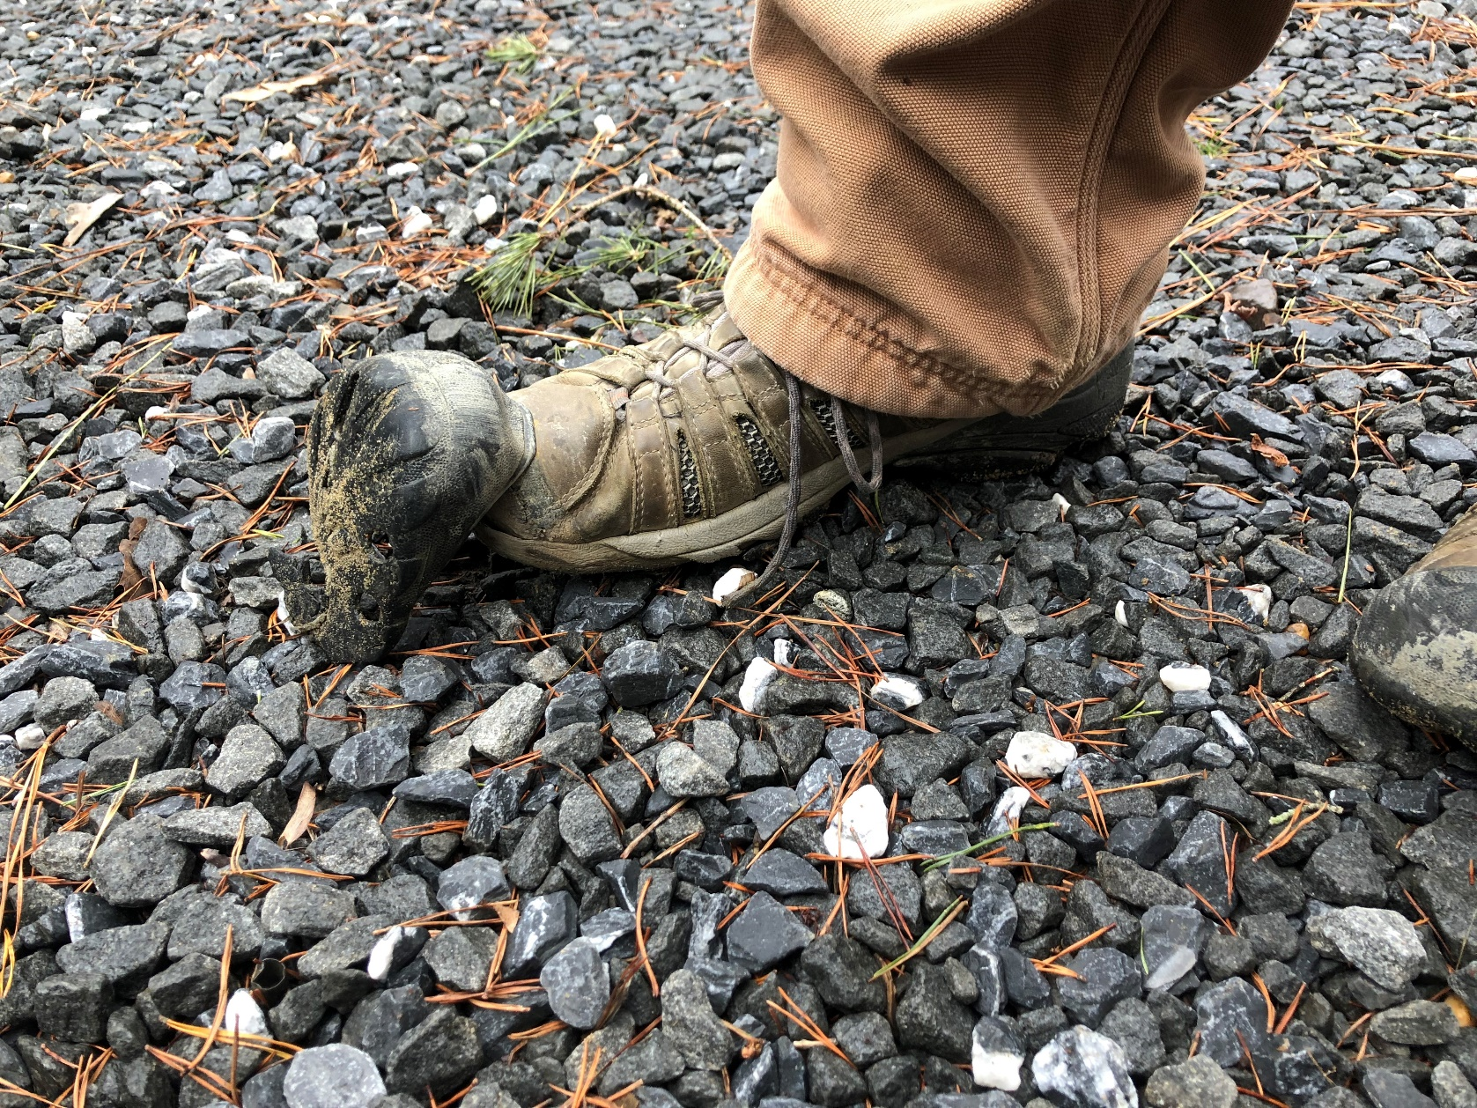

Can you see (much less hit) all the targets in this position?

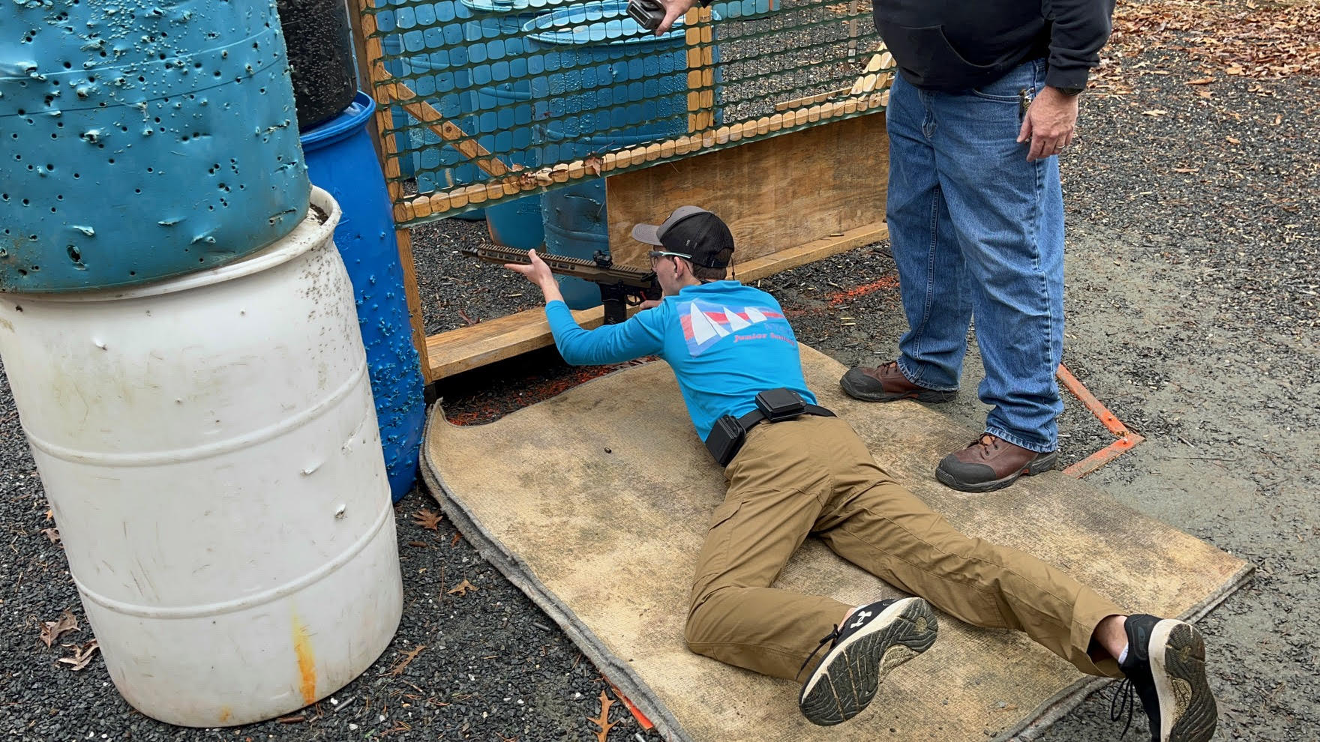

The cloudy conditions made for some great fireworks!

