Sanner’s Carbine Classic February Match Report
2/28/2021

This February Carbine Classic match was wild, wet, and wonderful! A total of 25 competitors braved the conditions to prove their dedication in the face of the downpour.

After a late-night simplification of the stages to reduce setup and teardown given the rainy forecast we happened upon a great balance of simplicity, low round count, and fun stages that gave competitors numerous interesting challenges. For example, one stage could be completed in exactly 11 rounds and therefore did not technically require a reload, however given the tricky long-distance shots required at the very end of the stage (around cover no less!) most people ended up stuffing more rounds in the gun and sending more lead downrange just to be safe.

We had a few more novice shooters came out for this match, and what a match to make their first! I can promise those competitors that this match is normally a little drier…but not necessarily any easier! In addition to these fresh faces, we have had many former novices returning to hone their skills and become grizzled veterans of the Carbine Classic.

Of course, as you might have guessed from the above, the weather was a big factor for this match. As the targets were being stapled there was faint mist in the air, and it even looked as though it might be clearing up. However, we decided to use waterproof targets and pasters just in case and that sure was the right move. As the day went on the rain steadily got heavier becoming nearly a downpour at times. Competitors, rifles, and gear were soaked to the point of failure; some rifles became manually operated, “waterproof” clothing was no longer, electronic scorepads became balky, and even a few shot timers bit the dust! But in the end, everybody rose to the challenge, forged ahead, embraced the suck, and finished off the match without incident

While the rain soaked everyone, those in Prepper division were weighed down with even more sogginess as their kit slowly became completely waterlogged. Prepper competitors are required to carry everything they used throughout the match on their person throughout the day and every course of fire, which adds to the challenge when the going gets tough. Congratulations are due to every Prepper for completing the match, and especially to Anibal Delgado who made it look easy winning Prepper division and placing 7th overall!

Included below is the link to the scores posted on Practiscore as well as a couple photos snagged during the match.

https://practiscore.com/results/new/128917

Special recognition must be given to Mike Hansen as the top Active Duty competitor, Gerald Turner as the high senior, Andrea Swierczek as the high lady, and finally Jordan Bowling as top Junior! Great shooting!

The next match will be May 29th, which promises to bring springtime warmth and plenty of sunshine (ha!). Sign up information will be provided separately; stay tuned to the Sanner’s website for the status of upcoming matches.

-Jake Swierczek

Fire and Rain:

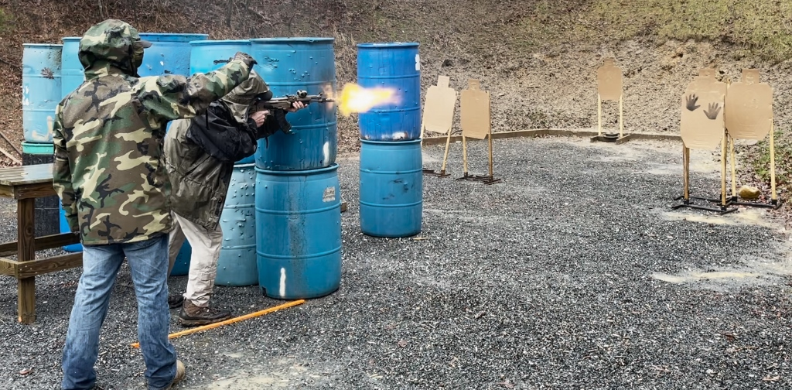

Doing the Lefty Reload Reach-around:

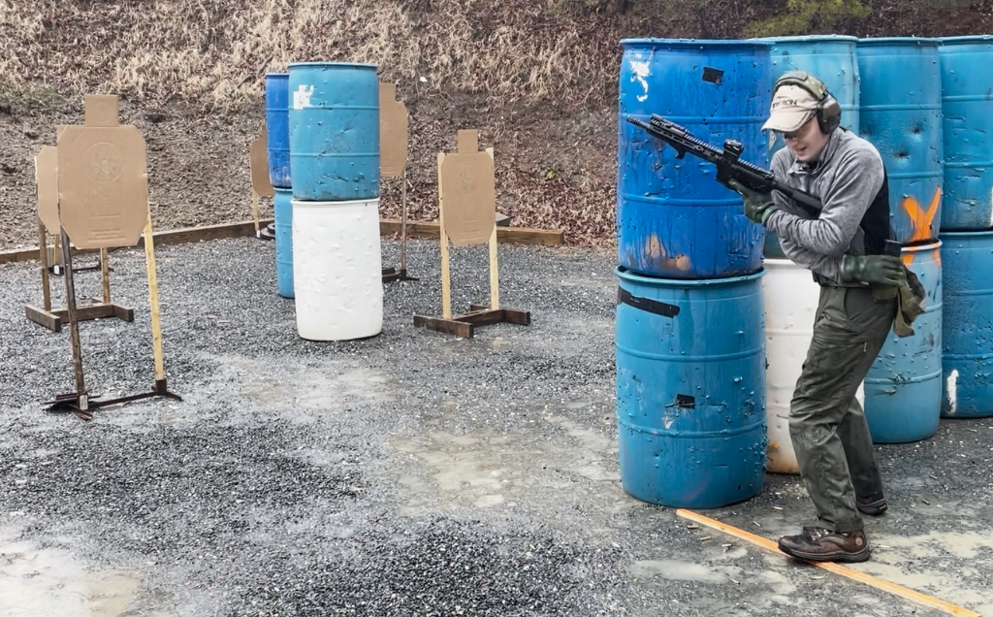

Suppressor Steambath:

