Sanners Lake “Frozen Chosin” Match Report
02/13/2016
Although nowhere near as brutal as the actual conditions the United States Marines and other fighters experienced during the Battle of the Chosin reservoir in the winter of 1950, the weather was miserable enough at Sanners Lake on Saturday for five intrepid shooters to gain a new appreciation for the service and sacrifice of the “Chosin Few” during the first annual Sanners Lake “Frozen Chosin” match.

Bone-chilling winds were whipping off the ice-covered ponds as the shooters settled in with their M1 Carbines, lining up on SR-1 targets at 100 yards. The match format consisted of a prone slowfire stage, two strings of prone rapid fire, and one standing slowfire stage. The M1 Carbine was the gun of choice for this match due to its (in)famous reputation during the Korean War, particularly under adverse conditions.

All of the shooters persevered, however, and the carbines belied their reputation, with decent scores turned in from top to bottom. Dick Chadwick, no doubt familiar with miserable conditions, turned in the top score of the day with a 252-0, a stellar score on even the nicest day. Chris Moe and Jake Swierczek (who drove through blowing snow and salt all the way from WV to make the match) took second and third place with a 236-2 and 227-1, respectively. Of course, all of the shooters were winners for defying the elements and showing that it takes more than mere winter weather advisories to keep a dedicated rifleman off the firing line!

See below for scores and pictures from the match. Congratulations to all the shooters! Oh, and as the weather gets warmer, be sure to grab your war relic or replica and join us as the monthly “Woodstock” matches. Or, grab your Garand or AR or even your hunting rifle and join us at a high power match...there are Sporting Rifle Matches, Vintage Military Matches, and of course the standard National Match Course held throughout the summer at Sanners. So whatever your taste in fun and friendly competition, there’s a flavor to suit it!
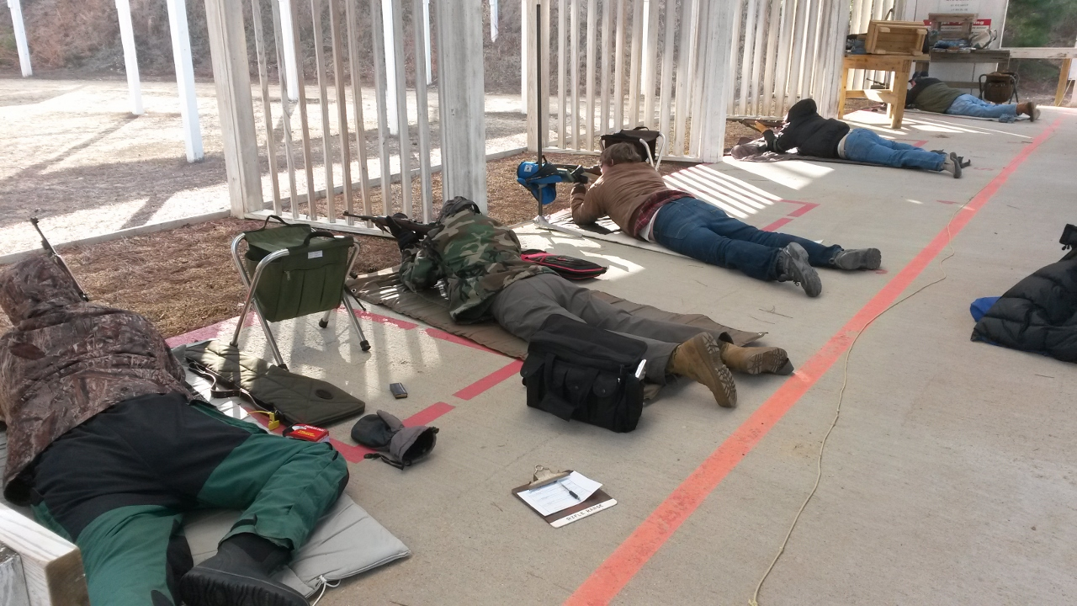

Scores:
SR-1 Target 100 yards
Place | Name | Prone | Prone Rapid | Standing | Aggregate
1 | Dick Chadwick | 90-0 | 87-0 | 75-0 | 252-0
2 | Chris Moe | 85-0 | 84-1 | 67-1 | 236-2
3 | Jake Swierczek | 90-1 | 75-0 | 62-0 | 227-1
4 | Eric Chase | 75-0 | 67-0 | 44-0 | 186-0
5 | Doug Trollinger | 55-0 | 68-0 | 55-0 | 178-0

