Sanner’s Lake IR5050 Rimfire Benchrest Match Report
17 October 2021

Legitimate autumn weather finally showed up in Southern Maryland as brisk and chilly breezes made for challenging conditions at the October IR5050 match at Sanner’s Lake. The autumn gusts didn’t stop Greg Banta and his Vudoo V-22S from putting together an excellent 249-11X on his first string, though, taking the high individual score with ease. And while his subsequent strings didn’t quite match that score, Greg and his Vudoo did well enough to take high combined score with a strong 737-33X. Meanwhile, Jeff Potts kept nipping at Greg’s heels with a super 243-3X individual and 705-9X combined, cresting the magic 700 mark and cruising into second place combined. See all the scores and a picture from the match below.

Thanks to all of our regular shooters and also the newcomers who came out to the range this year to support our rimfire matches. Keep an eye on the Sanner’s Lake website calendar for next year’s schedule...in the meantime, give your rifle a coat of oil, perhaps tear it down and tune it up, and we’ll catch you at the range next year!

Individual Scores:

Place | Name | Rifle | Score | X
1 | Greg Banta | Vudoo V-22S | 249 | 11
2 | Greg Banta | Vudoo V-22S | 244 | 12
3 | Greg Banta | Vudoo V-22S | 244 | 10
4 | Jeff Potts | CZ 457 Custom | 243 | 3
5 | Jeff Potts | CZ 457 Custom | 231 | 3
6 | Jeff Potts | CZ 457 Custom | 231 | 3
7 | Dick Chadwick | Ruger 10/22 | 228 | 6
8 | Mark Swierczek | Tactical Solutions 10/22 | 215 | 1
9 | Frank Torbert | Ruger Precision Rimfire | 211 | 5
10 | Kaiden Jones | Ruger Precision Rimfire | 206 | 1
11 | Dick Chadwick | Ruger 10/22 | 204 | 3
12 | Mark Swierczek | Tactical Solutions 10/22 | 200 | 1
13 | Kaiden Jones | Ruger Precision Rimfire | 196 | 1
14 | Dick Chadwick | Ruger 10/22 | 194 | 2
15 | Frank Torbert | Ruger Precision Rimfire | 193 | 1
16 | Frank Torbert | Ruger Precision Rimfire | 190 | 2
17 | Kaiden Jones | Ruger Precision Rimfire | 187 | 3
18 | Mark Swierczek | Tactical Solutions 10/22 | 171 | 0
Note: 250 points possible. Ties broken by X count, then by first target block with higher points.
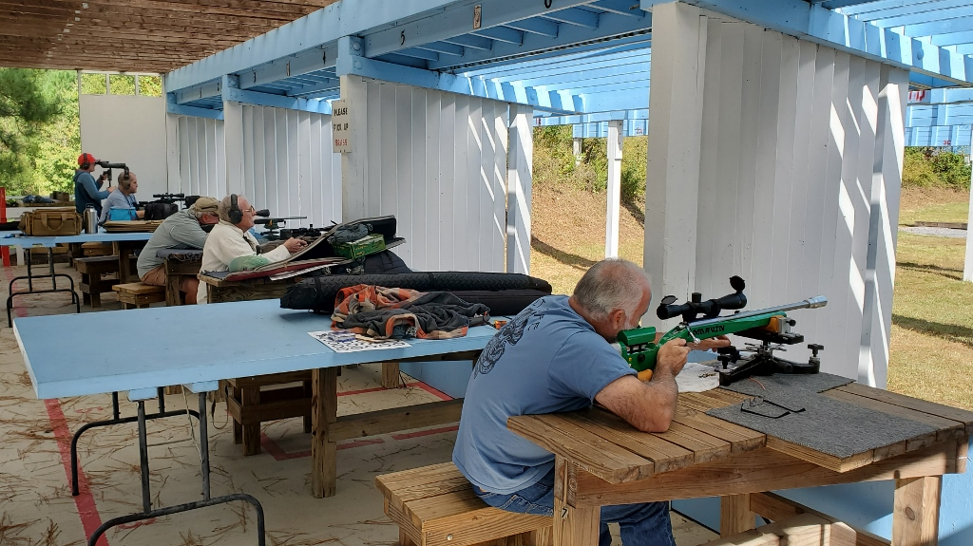
Combined Scores:

Place | Name | Rifle | String 1 | X | String 2 | X | String 3 | X | Total | X
1 | Greg Banta | Vudoo V-22S | 249 | 11 | 244 | 10 | 244 | 12 | 737 | 33
2 | Jeff Potts | CZ 457 Custom | 231 | 3 | 231 | 3 | 243 | 3 | 705 | 9
3 | Dick Chadwick | Ruger 10/22 | 204 | 3 | 194 | 2 | 228 | 6 | 626 | 11
4 | Frank Torbert | Ruger Precision Rimfire | 211 | 5 | 193 | 1 | 190 | 2 | 594 | 8
5 | Kaiden Jones | Ruger Precision Rimfire | 187 | 3 | 206 | 1 | 196 | 1 | 589 | 5
6 | Mark Swierczek | Tactical Solutions 10/22 | 200 | 1 | 215 | 1 | 171 | 0 | 586 | 2
Note: 750 total points possible. Ties broken by X count.

