Sanner’s Lake IR5050 Rimfire Benchrest Match Report
1 May 2022

It was a cloudy afternoon but luckily the rain never materialized making for a pleasant afternoon of shooting at the May IR5050 match at Sanner’s lake. A full firing line of shooters stepped up to the challenge of keeping rounds pointed towards the ten ring as the occasionally breezy conditions kept the wind flags spinning every which way downrange! In the combined category it was Greg Banta and his Vudoo taking the win with a string of nearly matching scores in the 240’s for a combined total of 734-24X, showing you can work with the wind if you have the patience. Likewise Jeff Potts and his custom CZ put together another series of strong scores in the high 230’s to take second place with an excellent 708-17X. Meanwhile, Ling Xu came out of nowhere with his Bergara and shot all three strings at once (off the platform and barricade no less!) and took third with a superb 685-11X. In the individual category the results were similar, with Greg, Jeff and Ling keeping their scores all clustered together near the top while Anthony Kirby nipped at their heels just below them. Meanwhile Jeff Heisler and Josh Kelly kept duking it out, trading places back and forth further down the line! See all the scores and details below.

Thanks to all the shooters, old and new, who filled up the benches and kept the action lively. Next match is on June 5th, see you there!

Combined Scores:

Place | Name | Rifle | String 1 | X | String 2 | X | String 3 | X | Total | X
1 | Greg Banta | Vudoo V-22S | 245 | 3 | 244 | 11 | 245 | 10 | 734 | 24
2 | Jeff Potts | CZ 457 Lilja | 234 | 5 | 237 | 7 | 237 | 5 | 708 | 17
3 | Ling Xu | Bergara B14 | 224 | 3 | 232 | 3 | 229 | 5 | 685 | 11
4 | Anthony Kirby | Kidd Classic 10/22 | 203 | 3 | 202 | 3 | 209 | 3 | 614 | 9
5 | Jeff Heisler | Ruger 10/22 | 175 | 0 | 165 | 0 | 202 | 3 | 542 | 3
6 | Josh Kelley | Ruger Precision Rimfire | 161 | 1 | 185 | 1 | 166 | 1 | 512 | 3
7 | Alston Rush | Ruger 77/22 | 118 | 0 | 162 | 1 | 152 | 2 | 432 | 3
8 | William Heisler | CZ 452 Scout | 72 | 0 | 71 | 0 | 93 | 0 | 236 | 0
Note: 750 total points possible. Ties broken by X count.

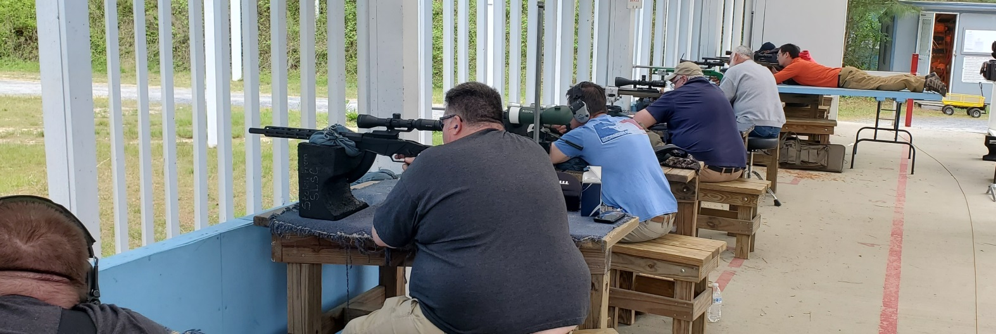

Individual Scores:

Place | Name | Rifle | Score | X
1 | Greg Banta | Vudoo V-22S | 245 | 10
2 | Greg Banta | Vudoo V-22S | 245 | 3
3 | Greg Banta | Vudoo V-22S | 244 | 11
4 | Jeff Potts | CZ 457 Lilja | 237 | 7
5 | Jeff Potts | CZ 457 Lilja | 237 | 5
6 | Jeff Potts | CZ 457 Lilja | 234 | 5
7 | Ling Xu | Bergara B14 | 232 | 3
8 | Ling Xu | Bergara B14 | 229 | 5
9 | Ling Xu | Bergara B14 | 224 | 3
10 | Anthony Kirby | Kidd Classic 10/22 | 209 | 3
11 | Anthony Kirby | Kidd Classic 10/22 | 203 | 3
12 | Anthony Kirby | Kidd Classic 10/22 | 202 | 3
13 | Jeff Heisler | Ruger 10/22 | 202 | 3
14 | Josh Kelley | Ruger Precision Rimfire | 185 | 1
15 | Jeff Heisler | Ruger 10/22 | 175 | 0
16 | Josh Kelley | Ruger Precision Rimfire | 166 | 1
17 | Jeff Heisler | Ruger 10/22 | 165 | 0
18 | Alston Rush | Ruger 77/22 | 162 | 1
19 | Josh Kelley | Ruger Precision Rimfire | 161 | 1
20 | Alston Rush | Ruger 77/22 | 152 | 2
21 | Alston Rush | Ruger 77/22 | 118 | 0
22 | William Heisler | CZ 452 Scout | 93 | 0
23 | William Heisler | CZ 452 Scout | 72 | 0
24 | William Heisler | CZ 452 Scout | 71 | 0
Note: 250 points possible. Ties broken by X count, then by first target block with higher score.
