Sanner’s Lake Silhouette Match Report – May 2023

Beautiful spring weather brought out the steel shooters ready to break some eggs at the inaugural Sanner’s Lake silhouette match of 2023. The action was hot and the eggs were cooking but when the smoke cleared a total of three, count ‘em three, shooters ended up with near-perfect scores of 39 eggs dropped! So, it was time to break out the tie-breaking rules...which meant Greg Banta took the victory by dropping all his eggs at 100 yards. Congrats to Greg! Also a shout-out goes to Dave Heilmeier for a near-match-winning performance his first time out, a testament to practice and a well-sighted-in rifle. Nice job, Dave! See all the scores and details below:

Place | Name | Rifle | 40m | 60m | 77m | 100y | Total
1 | Greg Banta | Vudoo V-22 | 10 | 10 | 9 | 10 | 39
2 | Dave Heilmeier | Anschutz 1761 HB | 10 | 10 | 10 | 9 | 39
3 | Mark Swierczek | Anschutz 1416 | 10 | 10 | 10 | 9 | 39
4 | Frank Torbert | Ruger Precision Rimfire | 10 | 9 | 8 | 7 | 34
5 | Mike Bourque | Tikka T1x | 10 | 8 | 3 | 5 | 26
6 | Brian Forsyth | Ruger 10/22 | 3 | 0 | 2 | 1 | 6
Note: ties broken by distance: high score at 100y, followed by 77m, 60m, and finally 40m

The next match will be on June 18th, plenty of time to dial in your rifle and make a run for top egg.

See you there!

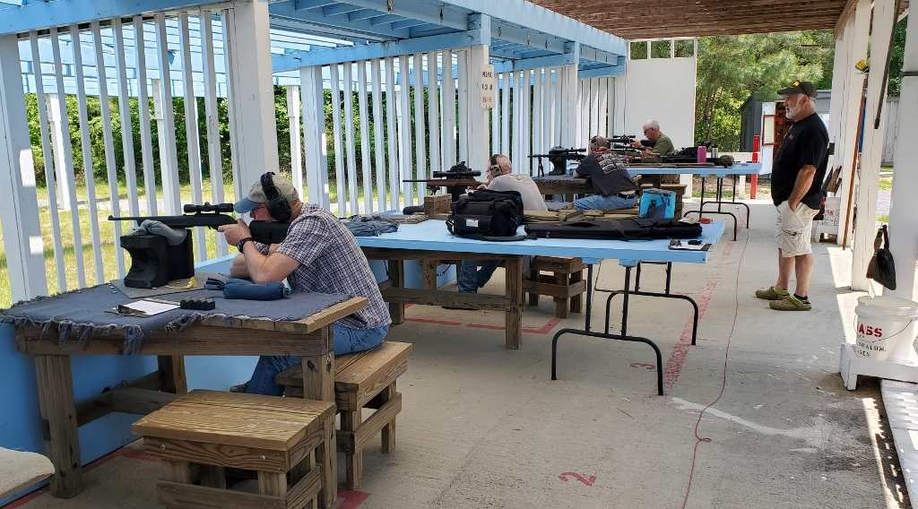

The hot pink eggs were a hit...literally!

