A crisp and chilly early April day that felt more like early March didn’t deter five shooters from making it out to Sanner’s Lake for the first rimfire sporter match of the year! Quite a few new faces were present amongst the regulars on the line but you wouldn’t know it from the scores which were strong from top to bottom. And the scores should only get better with time considering some of the newcomers were still sorting out their positions and figuring out the correct target at which to aim! In any event, when the smoke cleared, a good time was had by all, and hopefully most will be back for the next match. See all the scores and some pictures from the match below.
Thanks to all who made it out to the range to begin the shooting year with a decent turnout and strong scores! The next match will be on 14 May, same time and place. See you then!

CMP B-19 Target 50/25yards
Place | Name | Rifle | Sights | Prone  Slow | X | Prone  Rapid | X | Sitting  Slow | X | Sitting  Rapid | X | Standing  Slow | X | Standing  Rapid | X | Total | X
1 | Jake Swierczek | Ruger 10/22 | Scope | 100 | 7 | 99 | 6 | 100 | 8 | 97 | 5 | 100 | 3 | 98 | 4 | 594 | 33
2 | Jeff Heisler | Ruger 10/22 | Scope | 93 | 0 | 93 | 1 | 90 | 1 | 92 | 0 | 90 | 0 | 90 | 1 | 548 | 3
3 | Bruce Feldman | Compass Lake .22 | Dot | 95 | 2 | 90 | 1 | 94 | 1 | 93 | 1 | 73 | 1 | 95 | 3 | 540 | 9
4 | Jason Ehlers | Iver Johnson | Irons | 95 | 3 | 83 | 2 | 66 | 0 | 79 | 0 | 90 | 3 | 86 | 1 | 499 | 9
5 | Tom Reider | CZ 455 American | Scope | 87 | 1 | 73 | 1 | 85 | 2 | 74 | 1 | 86 | 0 | 84 | 1 | 489 | 6
600 total points possible. Ties broken by X count.
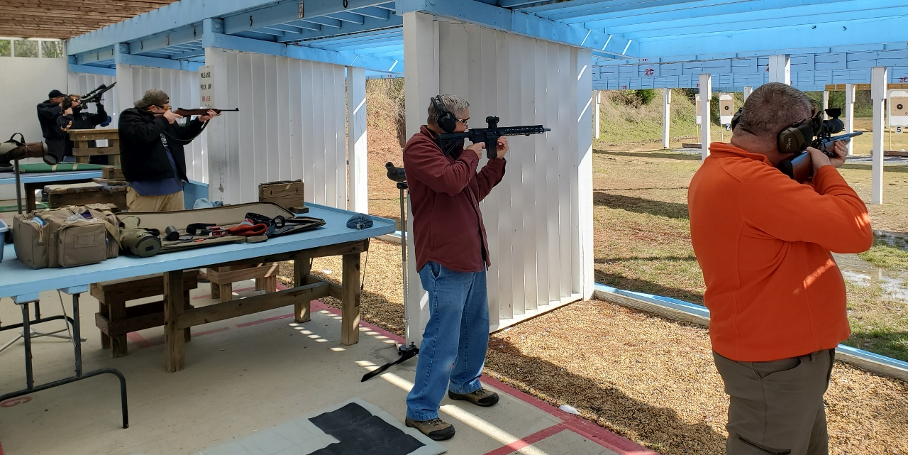

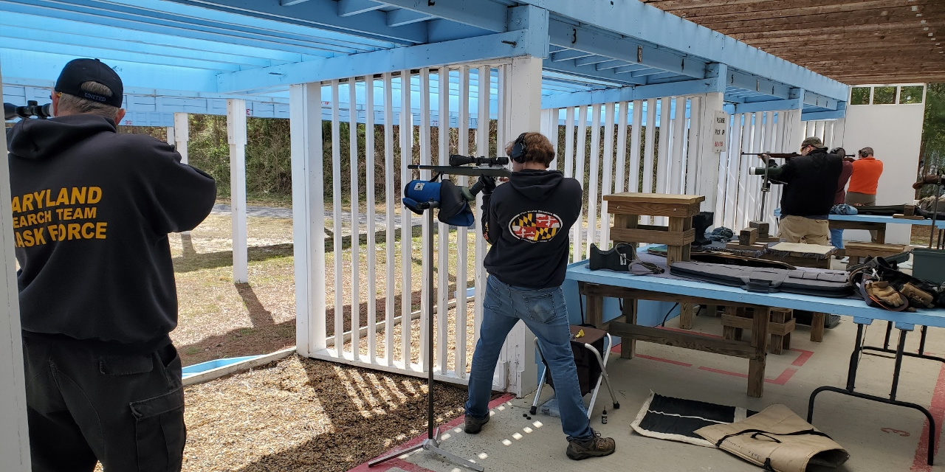

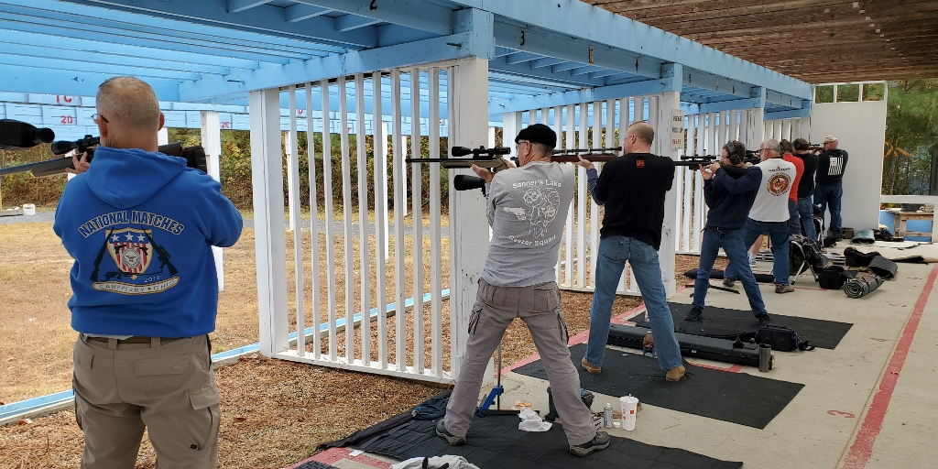

Notes on Rimfire Sporter:
Stage 1 = prone slow fire, 10 shots in 10 minutes, CMP B-19 target at 50 yards
Stage 2 = prone rapid fire, two strings of 5 shots in 30 seconds, CMP B-19 target at 50 yards
Stage 3 = sitting or kneeling slow fire, 10 shots in 10 minutes, CMP B-19 target at 50 yards
Stage 4 = sitting or kneeling rapid fire, two strings of 5 shots in 30 seconds, CMP B-19 target at 50 yards
Stage 5 = standing slow fire, 10 shots in 10 minutes, CMP B-19 target at 25 yards
Stage 6 = standing rapid fire, two strings of 5 shots in 30 seconds, CMP B-19 target at 25 yards

