Sanner’s Lake Woodstock Match Report – July 2020

Classic southern Maryland steamy July weather didn’t stop seven sweaty shooters from making it out to the long-delayed but much-anticipated first Sanner’s Lake Woodstock match of 2020! In the combined score category Jonathan Ramsey and his Schmidt-Rubin made it look easy, notching a consistent set of mid-90’s totaling up to an excellent 285-3X to take the win. In the individual category, Mark Swierczek and his BM-59 squeaked by Jonathan’s Schmidt-Rubin to take the top spot with a strong 98-2X. Note that over half the individual scores were in the 90’s, an excellent showing for these old warhorses!

Thanks to everybody for making it out to the range after the long layoff and putting rounds into the ten ring. The next Woodstock match will be on August 20th, see you then!

Combined Scores:
SR-21 Target 100 yards
Place | Name | Rifle | String1 | X | String2 | X | String3 | X | Total | X
1 | Jonathan Ramsey | Schmidt–Rubin 1911 | 97 | 2 | 94 | 0 | 94 | 1 | 285 | 3
2 | Mark Swierczek | BM 59 | 98 | 2 | 91 | 0 | 92 | 1 | 281 | 3
3 | Paul Stephens | Springfield M1903 | 87 | 0 | 94 | 3 | 91 | 1 | 272 | 4
4 | Ron Ferguson | Springfield M1 Garand | 88 | 0 | 90 | 1 | 93 | 1 | 271 | 2
5 | Dick Chadwick | Springfield M1 Garand | 86 | 1 | 92 | 1 | 81 | 0 | 259 | 2
6 | Asher Maroot | Inland M1 Carbine | 84 | 1 | 81 | 1 | 79 | 0 | 244 | 2
7 | Tony Skalamera | M14 | 62 | 1 | 48 | 0 | 68 | 0 | 178 | 1
300 total points possible. Ties broken by X's and then by highest individual string.

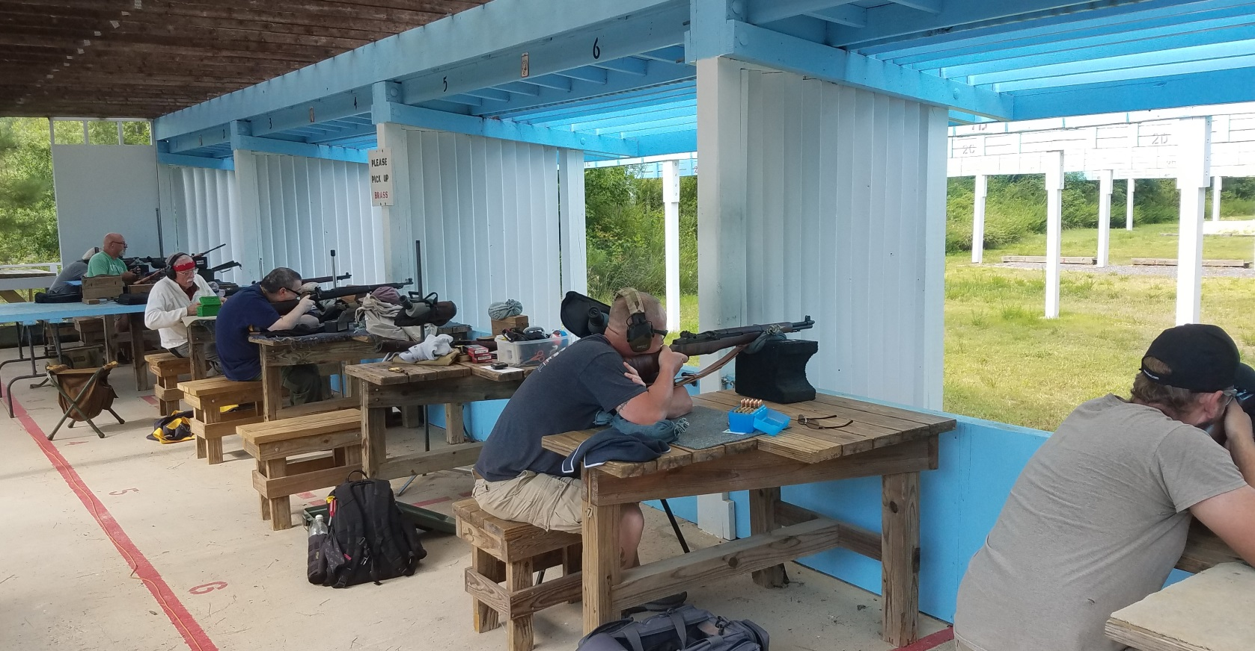

Individual Scores:
SR-21 Target 100 yards
Place | Name | Rifle | Caliber | Score | X
1 | Mark Swierczek | BM 59 | 7.62×51mm NATO | 98 | 2
2 | Jonathan Ramsey | Schmidt–Rubin 1911 | 7.5×55mm Swiss | 97 | 2
3 | Paul Stephens | Springfield M1903 | .30-06 Springfield | 94 | 3
4 | Jonathan Ramsey | Schmidt–Rubin 1911 | 7.5×55mm Swiss | 94 | 1
5 | Jonathan Ramsey | Schmidt–Rubin 1911 | 7.5×55mm Swiss | 94 | 0
6 | Ron Ferguson | Springfield M1 Garand | .30-06 Springfield | 93 | 1
7 | Dick Chadwick | Springfield M1 Garand | .30-06 Springfield | 92 | 1
8 | Mark Swierczek | BM 59 | 7.62×51mm NATO | 92 | 1
9 | Paul Stephens | Springfield M1903 | .30-06 Springfield | 91 | 1
10 | Mark Swierczek | BM 59 | 7.62×51mm NATO | 91 | 0
11 | Ron Ferguson | Springfield M1 Garand | .30-06 Springfield | 90 | 1
12 | Ron Ferguson | Springfield M1 Garand | .30-06 Springfield | 88 | 0
13 | Paul Stephens | Springfield M1903 | .30-06 Springfield | 87 | 0
14 | Dick Chadwick | Springfield M1 Garand | .30-06 Springfield | 86 | 1
15 | Asher Maroot | Inland M1 Carbine | .30 Carbine | 84 | 1
16 | Asher Maroot | Inland M1 Carbine | .30 Carbine | 81 | 1
17 | Dick Chadwick | Springfield M1 Garand | .30-06 Springfield | 81 | 0
18 | Asher Maroot | Inland M1 Carbine | .30 Carbine | 79 | 0
19 | Tony Skalamera | M14 | .308 Winchester | 68 | 0
20 | Tony Skalamera | M14 | .308 Winchester | 62 | 1
21 | Tony Skalamera | M14 | .308 Winchester | 48 | 0
100 points possible. Ties broken by X's and then by fewest hits of lowest value.

