Sanner’s Lake Woodstock Match Report – July 2021

We achieved classic Southern Maryland sticky summer weather as the July Woodstock match kicked off on a steamy weekday afternoon at Sanner’s Lake. Four faithful competitors shook off the sweat and hunkered down with their vintage iron and launched lead downrange to see if their old rifles (and corresponding trigger activators) still had what it takes. Jonathan Ramsey decided to bring a different rifle this time, a vintage Schmidt-Rubin shooting classic Swiss GP11 ammo, but the change didn’t seem to matter as he once again grabbed first place in both the combined and individual categories, edging closer once again that that elusive perfect 100! Right behind him were both Ron Ferguson and Asher Maroot shooting iconic M1 Garands, with Ron taking second place combined and Asher right behind Jonathan in the individual score category. Meanwhile new shooter Jim Kay saw his best score on his first string when he fired all of his shots in less than two minutes...sometimes shooting quickly and getting it over with can be the best approach! Still great scores with his untested SKS at 100 yards; hopefully Jim will be back for more. See all the scores and details below.

Thanks as always to the stalwarts who shrugged off the sweltering weather and put their rifles to the test. Our next match is on 19 August...perhaps it won’t be quite so hot by then (ha!). See you there!

Combined Scores:
SR-21 Target 100 yards
Place | Name | Rifle | String1 | X | String2 | X | String3 | X | Total | X
1 | Jonathan Ramsey | Schmidt–Rubin | 97 | 5 | 96 | 1 | 99 | 2 | 292 | 8
2 | Ron Ferguson | Springfield M1 Garand | 89 | 1 | 86 | 1 | 85 | 0 | 260 | 2
3 | Asher Maroot | Winchester M1 Garand | 84 | 0 | 74 | 0 | 92 | 2 | 250 | 2
4 | Jim Kay | Yugo SKS 59/66 | 63 | 0 | 45 | 0 | 59 | 0 | 167 | 0
300 total points possible. Ties broken by X's and then by highest individual string.

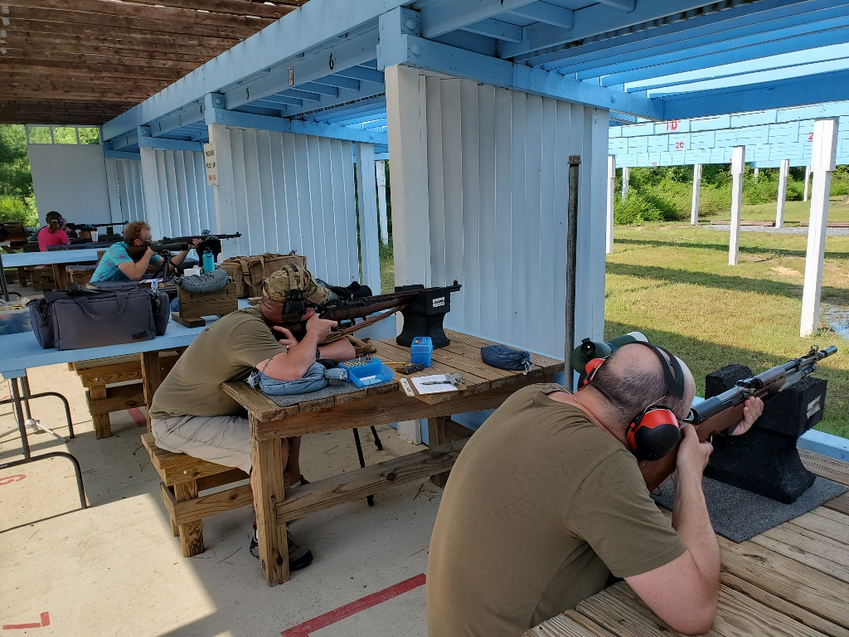

Individual Scores:
SR-21 Target 100 yards
Place | Name | Rifle | Caliber | Score | X
1 | Jonathan Ramsey | Schmidt–Rubin | 7.5×55mm Swiss | 99 | 2
2 | Jonathan Ramsey | Schmidt–Rubin | 7.5×55mm Swiss | 97 | 5
3 | Jonathan Ramsey | Schmidt–Rubin | 7.5×55mm Swiss | 96 | 1
4 | Asher Maroot | Winchester M1 Garand | .30-06 Springfield | 92 | 2
5 | Ron Ferguson | Springfield M1 Garand | .30-06 Springfield | 89 | 1
6 | Ron Ferguson | Springfield M1 Garand | .30-06 Springfield | 86 | 1
7 | Ron Ferguson | Springfield M1 Garand | .30-06 Springfield | 85 | 0
8 | Asher Maroot | Winchester M1 Garand | .30-06 Springfield | 84 | 0
9 | Asher Maroot | Winchester M1 Garand | .30-06 Springfield | 74 | 0
10 | Jim Kay | Yugo SKS 59/66 | 7.62×39mm | 63 | 0
11 | Jim Kay | Yugo SKS 59/66 | 7.62×39mm | 59 | 0
12 | Jim Kay | Yugo SKS 59/66 | 7.62×39mm | 45 | 0
100 points possible. Ties broken by X's and then by fewest hits of lowest value.

Top target of the day:

