Sanner’s Lake Woodstock Match Report – March 2023

It was a beautiful day at the range, certainly a rare event for March this year, and a surplus of shooters came out to shake off the winter cobwebs and take full advantage of the sunny and nearly-windless afternoon, filling the benches from end to end and then some! Chris Moe, founder of the Woodstock match years ago, rejoined the group and showed everyone how it’s done as the bullets from his ’03 Springfield hit the ten ring more often than not, taking the high combined score victory with an excellent 289-8X! Not to be outdone, Jonathan Ramsey and his ’03 kept the pressure on, notching a super-consistent set of scores to take the second place slot with a superb 286-8X. Filling out the podium, and in keeping with the theme of winning Springfields, Greg Banta and his ’03 put together a strong 269-1X to slip into third place, just one X ahead of Ron Ferguson and his Garand in the tie-breaker. See all the scores and details below.

Congratulations to each of the winners and all of the shooters who put their classic military service rifles to the test in the critical crucible of competition. Of course, not every rifle made it to the end of the match unscathed, but the beauty of these old warhorses is we can rebuild them...and we can make them better! The next Woodstock match is on April 20th, see you there...

Combined Scores:

SR-21 Target 100 yards
Place | Name | Rifle | String1 | X | String2 | X | String3 | X | Total | X
1 | Chris Moe | Springfield M1903A3 | 95 | 2 | 97 | 2 | 97 | 4 | 289 | 8
2 | Jonathan Ramsey | Springfield M1903A3 | 95 | 3 | 95 | 2 | 96 | 3 | 286 | 8
3 | Greg Banta | 1903 Springfield | 88 | 0 | 94 | 1 | 87 | 0 | 269 | 1
4 | Ron Ferguson | Springfield M1 Garand | 88 | 0 | 91 | 0 | 90 | 0 | 269 | 0
5 | Mark Swierczek | Trapdoor Springfield | 88 | 0 | 87 | 0 | 90 | 2 | 265 | 2
6 | Jeremy Hanson | K98k Mauser | 90 | 1 | 89 | 0 | 84 | 0 | 263 | 1
7 | James Black | M1 Garand | 76 | 0 | 92 | 0 | 81 | 0 | 249 | 0
8 | Pat Patton | M1 Carbine Quality HW | 81 | 1 | 66 | 0 | 76 | 0 | 223 | 1
9 | Pat Patton | M1 Carbine Quality HW | 77 | 0 | 67 | 0 | 77 | 0 | 221 | 0
10 | Tim Kelly | M1 Carbine | 71 | 0 | 52 | 0 | 72 | 0 | 195 | 0
11 | Rick Mongello Sr. | K98 Mauser | 31 | 0 | 8 | 0 | 42 | 0 | 81 | 0
12 | Jeff Heisler | Hakim Rifle | 75 | 0 | withdrew, disabled rifle
300 total points possible. Ties broken by X's and then by highest individual string.

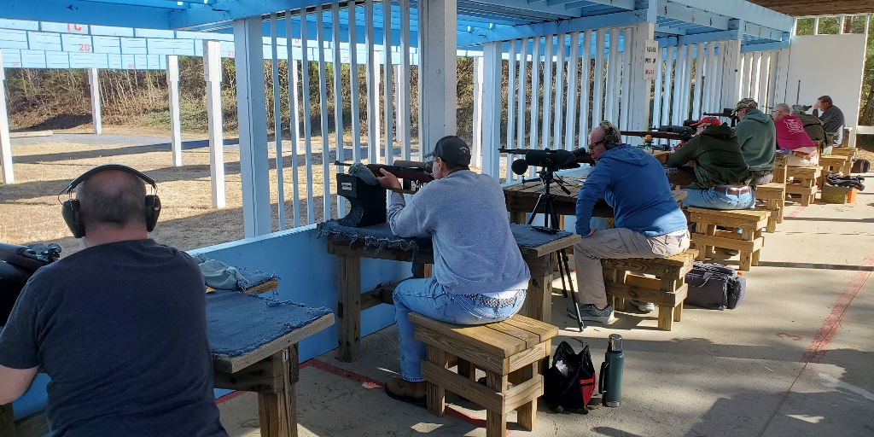
Individual Scores:
SR-21 Target 100 yards
Place | Name | Rifle | Caliber | Score | X
1 | Chris Moe | Springfield M1903A3 | .30-06 Springfield | 97 | 4
2 | Chris Moe | Springfield M1903A3 | .30-06 Springfield | 97 | 2
3 | Jonathan Ramsey | Springfield M1903A3 | .30-06 Springfield | 96 | 3
4 | Jonathan Ramsey | Springfield M1903A3 | .30-06 Springfield | 95 | 3
5 | Chris Moe | Springfield M1903A3 | .30-06 Springfield | 95 | 2
6 | Jonathan Ramsey | Springfield M1903A3 | .30-06 Springfield | 95 | 2
7 | Greg Banta | 1903 Springfield | .30-06 Springfield | 94 | 1
8 | James Black | M1 Garand | .30-06 Springfield | 92 | 0
9 | Ron Ferguson | Springfield M1 Garand | .30-06 Springfield | 91 | 0
10 | Mark Swierczek | Trapdoor Springfield M1884 | .45-70 Government | 90 | 2
11 | Jeremy Hanson | K98k Mauser | 8mm Mauser | 90 | 1
12 | Ron Ferguson | Springfield M1 Garand | .30-06 Springfield | 90 | 0
13 | Jeremy Hanson | K98k Mauser | 8mm Mauser | 89 | 0
14 | Greg Banta | 1903 Springfield | .30-06 Springfield | 88 | 0
15 | Ron Ferguson | Springfield M1 Garand | .30-06 Springfield | 88 | 0
16 | Mark Swierczek | Trapdoor Springfield M1884 | .45-70 Government | 88 | 0
17 | Greg Banta | 1903 Springfield | .30-06 Springfield | 87 | 0
18 | Mark Swierczek | Trapdoor Springfield M1884 | .45-70 Government | 87 | 0
19 | Jeremy Hanson | K98k Mauser | 8mm Mauser | 84 | 0
20 | Pat Patton | M1 Carbine Quality HW | .30 Carbine | 81 | 1
21 | James Black | M1 Garand | .30-06 Springfield | 81 | 0
22 | Pat Patton | M1 Carbine Quality HW | .30 Carbine | 77 | 0
23 | Pat Patton | M1 Carbine Quality HW | .30 Carbine | 77 | 0
24 | Pat Patton | M1 Carbine Quality HW | .30 Carbine | 76 | 0
25 | James Black | M1 Garand | .30-06 Springfield | 76 | 0
26 | Jeff Heisler | Hakim Rifle | 8mm Mauser | 75 | 0
27 | Tim Kelly | M1 Carbine | .30 Carbine | 72 | 0
28 | Tim Kelly | M1 Carbine | .30 Carbine | 71 | 0
29 | Pat Patton | M1 Carbine Quality HW | .30 Carbine | 67 | 0
30 | Pat Patton | M1 Carbine Quality HW | .30 Carbine | 66 | 0
31 | Tim Kelly | M1 Carbine | .30 Carbine | 52 | 0
32 | Rick Mongello Sr. | K98 Mauser | 8mm Mauser | 42 | 0
33 | Rick Mongello Sr. | K98 Mauser | 8mm Mauser | 31 | 0
34 | Rick Mongello Sr. | K98 Mauser | 8mm Mauser | 8 | 0
100 points possible. Ties broken by X's and then by fewest hits of lowest value.

Field expedient repairs were insufficient to return the Hakim to service...time for a trip to the depot!

