Sanner’s Lake Woodstock Match Report – October 2023

A crisp autumn afternoon greeted the five shooters who made it to the last Vintage Military “Woodstock” match of the year at Sanner’s Lake, and once again there were no ‘03 Springfields or Garands on the line! Instead we were greeted with a fascinating assortment of noteworthy rifles from various places around the globe, all being put to good use in the heat of competition. When the smoke cleared, it was the Italian and Belgian rifles leading the pack, with the German designs close behind. And right in the middle was Greg Banta’s pipsqueak M1 Carbine, holding its own against the big guns! Greg was no doubt getting his sights dialed in for the annual SLSC “Frozen Chosin” match in the January timeframe, and judging by his ever-increasing score he should be in good shape. See all the scores and details below. Thanks to the shooters who supported our matches this year and kept their vintage military rifles shooting straight and true. We’ll pick it up again next year; keep an eye on the club calendar for dates and times. Also don’t forget the aforementioned Frozen Chosin match coming early next year, probably in the January timeframe...more details to come as they become available. See you next year!

Combined Scores:
SR-21 Target 100 yards
Place | Name | Rifle | String 1 | X | String 2 | X | String 3 | X | Total | X
1 | Mark Swierczek | BM-59 | 92 | 2 | 92 | 0 | 95 | 2 | 279 | 4
2 | Ron Ferguson | FN FAL | 87 | 2 | 90 | 1 | 87 | 1 | 264 | 4
3 | Greg Banta | M1 Carbine | 78 | 0 | 84 | 1 | 86 | 0 | 248 | 1
4 | Jeremy Hanson | Mauser K98k | 81 | 1 | 82 | 0 | 80 | 1 | 243 | 2
5 | Nathaniel Swift | Gewehr 98 | 57 | 0 | 49 | 0 | 39 | 0 | 145 | 0
300 total points possible. Ties broken by X's and then by highest individual string.

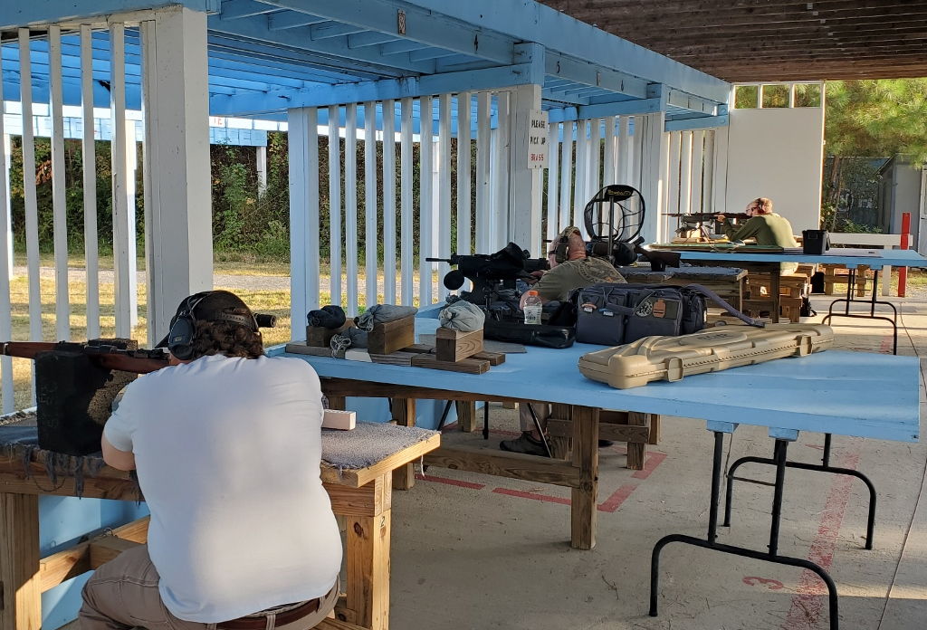
Individual Scores:

SR-21 Target 100 yards
Place | Name | Rifle | Caliber | Score | X
1 | Mark Swierczek | BM-59 | 7.62×51mm NATO | 95 | 2
2 | Mark Swierczek | BM-59 | 7.62×51mm NATO | 92 | 2
3 | Mark Swierczek | BM-59 | 7.62×51mm NATO | 92 | 0
4 | Ron Ferguson | FN FAL | 7.62×51mm NATO | 90 | 1
5 | Ron Ferguson | FN FAL | 7.62×51mm NATO | 87 | 2
6 | Ron Ferguson | FN FAL | 7.62×51mm NATO | 87 | 1
7 | Greg Banta | M1 Carbine | .30 Carbine | 86 | 0
8 | Greg Banta | M1 Carbine | .30 Carbine | 84 | 1
9 | Jeremy Hanson | Mauser K98k | 8mm Mauser | 82 | 0
10 | Jeremy Hanson | Mauser K98k | 8mm Mauser | 81 | 1
11 | Jeremy Hanson | Mauser K98k | 8mm Mauser | 80 | 1
12 | Greg Banta | M1 Carbine | .30 Carbine | 78 | 0
13 | Nathaniel Swift | Gewehr 98 | 8mm Mauser | 57 | 0
14 | Nathaniel Swift | Gewehr 98 | 8mm Mauser | 49 | 0
15 | Nathaniel Swift | Gewehr 98 | 8mm Mauser | 39 | 0
100 points possible. Ties broken by X's and then by fewest hits of lowest value.

Field expedient repairs are always a possibility at a Woodstock match!

