Sanner’s Carbine Classic January 2021 Match Report
1/30/2021

The January Carbine Classic match brought out some cool guns, gear, shooters, and weather as everyone not only competed against each other but against the elements to try and stay warm. Unfortunately, we missed the snow that came through the next day, but an enjoyable and distinctly wintry match was had nonetheless.

For this match, fun stages with minimal rules that gave competitors many shooting options were balanced by rigid drill stages that ensured competitors were exercising the basics in their dryfire routines. Variety was had with one stage using a moveable no shoot to prevent competitors from knowing what was coming, to a retention or “tactical” reload drill that forced competitors to top up their rifle while retaining the partially spent magazine. Not an easy task with gloved hands…or worse, non-gloved frozen hands!

There appears to be a cadre of competitors that come to enjoy these matches regularly, some bringing the gear they use in the line of duty, while others are simply prepared citizens taking the opportunity to make sure their gear works in a practical yet controlled environment. For this, prepper division is perfect and while we only had three competitors competing in Prepper division for this match there were plenty more plate carriers on the line. Although wearing prepper gear is not quite as brutal in the winter, those who take on the challenge deserve special recognition nonetheless: congratulations to Anibal Delgado for taking first in prepper! Additionally, James Paishon, and Michael Neal not only completed the match as well but put in solid prepper performances overall. Great work!

Congratulations also to our sole Ironman Asher Maroot for breaking out the Irons and doing very well!

Included below is the link to the scores posted on Practiscore as well as a couple photos snagged during the match.

https://practiscore.com/results/new/127188

Special recognition must be given to Mike Hansen as the top Active-Duty competitor, John Frank as the high senior, and finally Andrea Swierczek as the high lady! Great shooting!

The next match will be Sunday February 28th. Sign up information will be provided separately, stay tuned to the Sanner’s website for the status of upcoming matches.

-Jake Swierczek

Positively identifying your target is critical but can be tough under stress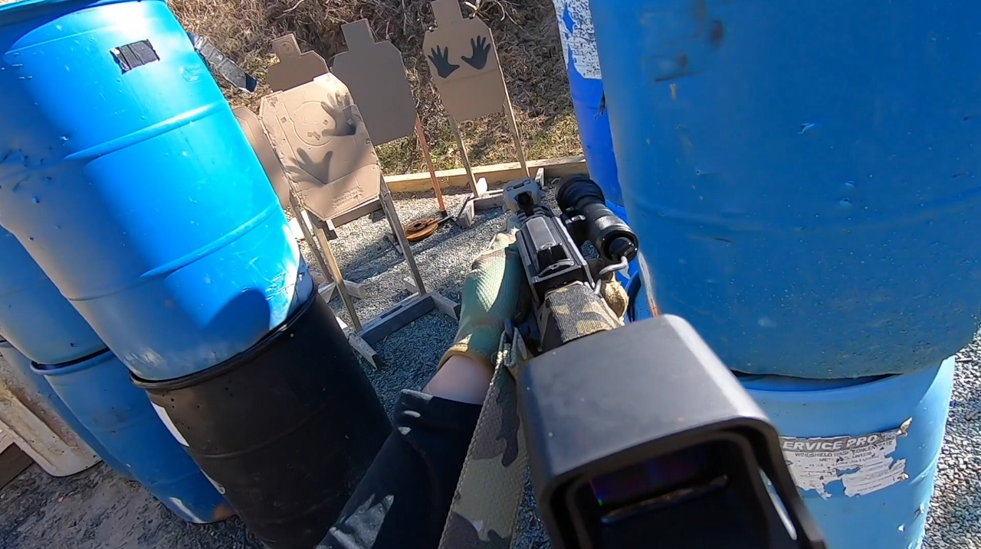

Muzzle brakes certainly get your attention at the beginning of a stage
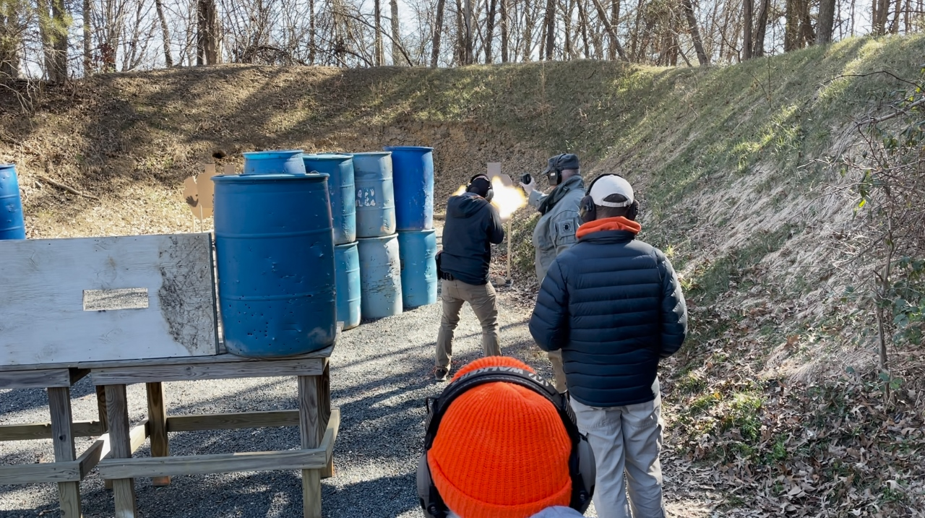

Bracing for a long shot while sucking smoke
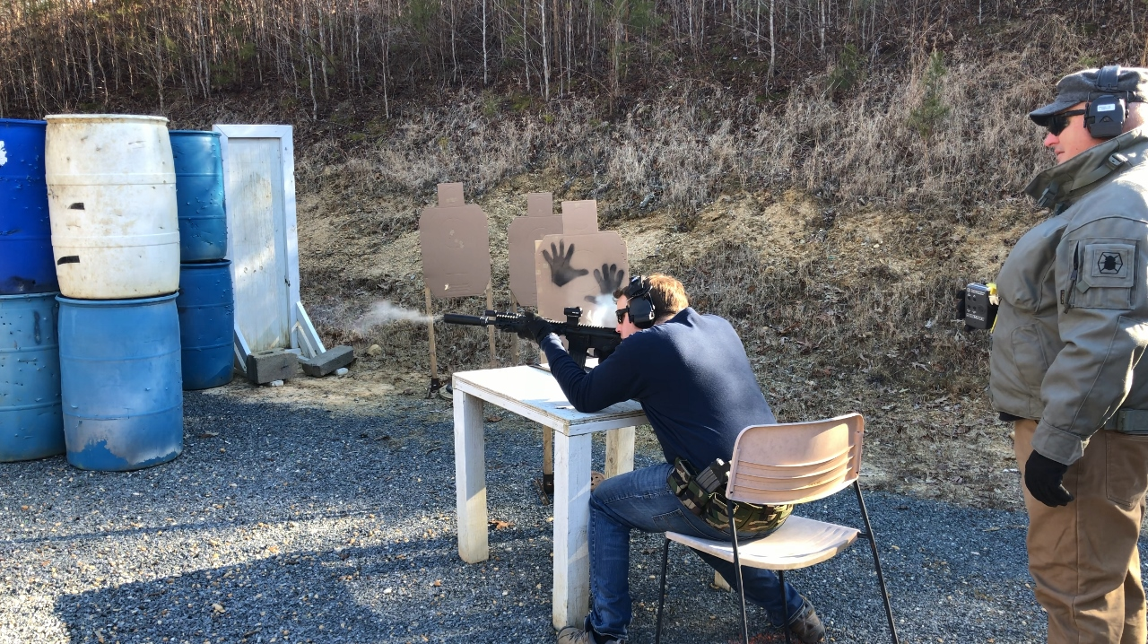

As the positions get weirder the shooting gets more interesting
